   WEB-BASED TYRE REPAIR AND RETREADING MANAGEMENT FOR

RYAK TIRES

By M.G Hasindu Thirasara

IM/2021/062

A report submitted in partial fulfilment of the requirements for the degree of Bachelor of Science Honors in Management and Information Technology (B.Sc. IT)

Name of the Supervisor: Dr. Thilini Mahanama

Department of Industrial Management

Faculty of Science

University of Kelaniya

Sri Lanka 2024/11

# **DECLARATION**

I hereby certify that this project and all the artefacts associated with it is my own work and it has not been submitted before nor is currently being submitted for any other degree program.

Full name of the student: M.G. Hasindu Thirasara

Student No: IM/2021/062

Signature of the student: ................................. Date: ……................

Name of the supervisor: Dr. Thilini Mahanama

Signature of the supervisor: ............................. Date: .........................................

# **ACKNOWLEDGMENT**

The completion of this project has been both challenging and fulfilling, and I owe much of its success to the support and guidance of many individuals.

First, I would like to express my deepest gratitude to my Project Supervisor, Dr. Thilini Mahanama, for her constant support, valuable feedback, and expert guidance throughout the semester. Her mentorship played a crucial role in refining the project and keeping me on track.

I also want to thank Mr. Lakshitha Viraj for his guidance in the early stages of the project. His insights helped me understand the project's objectives and structure, which gave me the confidence to move forward.

My sincere thanks go to Mr. Mohan Liyanapathirana, the owner of RYEK Tyre, for providing valuable industry knowledge and resources. His cooperation and expertise greatly enhanced the depth of this project.

I am also grateful to the staff members and judges who reviewed my video presentation. Their feedback helped me improve the system and refine its objectives.

To my parents and family, I am deeply thankful for their unwavering support, encouragement, and belief in me. Their constant help and motivation were crucial throughout this journey.

Lastly, I would like to thank my friends for their friendship, support, and helpful feedback. Their encouragement and fresh perspectives kept me motivated and focused, contributing greatly to the success of this project.

# **ABSTRACT**

This report outlines the development of a comprehensive web-based tyre repair and retreading management system, designed to modernize and streamline the operations of a tire retreading center. The system is aimed at replacing the current manual process, providing an efficient and centralized platform that manages the entire workflow—from customer orders and service requests to repair and retreading completion.

The system is structured to support multiple user roles, including the owner, workers, and customers, each with specific access to the relevant features. Key functionalities include customer account management, order placement, service tracking, work distribution, and payment management. Customers can easily place service requests, track the status of their tyres, and receive notifications when work is completed. The system also allows the owner to assign tasks to workers and keep track of progress, ensuring an efficient and organized workflow.

Core modules of the system include Order Management, Service Assignment, Payment Processing, and Notification System. These modules work together to enhance resource allocation, reduce turnaround times, and improve customer satisfaction. The system’s user-friendly interface ensures that both customers and workers can interact with the platform seamlessly.

This report delves into the system’s architecture, core functionalities, user roles, and workflows, illustrating how the management system optimizes the tyre service process. By transitioning from a manual to a digital system, this platform enhances productivity, streamlines operations, and ensures higher customer satisfaction. The implementation of this system represents a step forward in modernizing the tyre repair and retreading business, offering a more efficient, transparent, and customer-friendly service.

# **TABLE OF CONTENTS**

**DECLARATION** 2

**ACKNOWLEDGMENT** 3

**ABSTRACT** 4

**TABLE OF CONTENTS** 5

**LISTS OF FIGURES** 8

**LIST OF TABLES** 10

**CHAPTER 1 - INTRODUCTION** 10

**1.1. Introduction to RYAK TIRES** 11

**1.2. Business Process** 13

**1.3. Problem Definition** 14

**1.4. Aims and Objectives** 15

**1.5. Scope of the Project** 17

**1.6. Project Feasibility** 17

**1.7. Summary** 17

**CHAPTER 2 – SYSTEM ANALYSIS** 18

**2.1 Use Case Diagram for the Existing System** 19

**2.2 Use Case Description for Existing System** 20

**2.2.1 Use case Description for Customer Arrival** 20

**2.2.2 Use case Description for Create Invoice** 20

**2.2.3 Use case Description for Process Payment** 21

**2.2.4 Use case Description for Inspect Tire** 21

**2.2.5 Use case Description for Assign the Worker** 22

**2.2.5 Use case Description for Service Performed** 22

**2.2.6 Use case Description to Record the Service Details** 23

**2.3 Activity diagrams for the current business process** 24

**2.3.1 Customer Arrival and Service – Activity Diagram** 24

**2.3.2 Inventory Management – Activity Diagram** 25

**2.3.3 Manual Inventory Tracking – Activity Diagram** 26

**2.3.4 Payment & Invoice Generation – Activity Diagram** 27

**2.4 System Requirement Specification (SRS)** 28

**2.4.1 User story List** 29

**2.4.2 Functional requirements** 30

**2.4.3 Non-functional requirements** 32

**2.5 Complete Business System Options (BSOs)** 33

**2.6 Selected BSO with Justification** 37

**2.7 Summary** 37

**CHAPTER 3 – SYSTEM DESIGN** 38

**3.1 Use Case diagram for the proposed system** 39

**3.2 Use case identified for the Proposed System** 40

**3.2.1 Use case Description for Customer Registration** 40

**3.2.2 Use case Description for Login** 40

**3.2.3 Use case Description for Forgot Password** 41

**3.2.4 Use case Description for Online Order Submission** 41

**3.2.5 Use case Description for Check Order and Confirm or Cancel the Order** 41

**3.2.6 Use case Description for Process Payment** 42

**3.2.7 Use case Description for Work Distribution** 42

**3.2.8 Use case Description for Update the Status** 42

**3.2.9 Use case Description for Check the Status** 43

**3.2.9 Use case Description for Feedback** 43

**3.2.10 Use case Description for managing inventory** 43

**3.2.11 Use case Description for managing accounts** 44

**3.2.12 Use case Description for Inspect Customer Tire** 44

**3.3 Activity Diagrams for the Proposed System** 44

**3.3.1 Activity Diagram for Place Online Order** 45

**3.3.2 Activity Diagram for Work Distribution** 46

**3.3.3 Activity Diagram for Update the status** 47

**3.3.4 Activity Diagram for Payment & Digital Invoice** 48

**3.3.5 Activity Diagram for Manage Account** 49

**3.3.6 Activity Diagram for Manage Account** 50

**3.3.7 Activity Diagram for Owner in person inspects customer Tyre** 51

**3.3.8 Activity Diagram for Customer Registration** 52

**3.3.9 Activity Diagram for Check order and confirm the order** 53

**3.3.10 Activity Diagram for Customer Feedback** 54

**3.4 Class diagrams for the proposed system** 55

**3.4.1 Entity Class diagram for the proposed system** 55

**3.4.2 Controller Class diagram for the proposed system** 56

**3.4.3 Interface Class diagram for the proposed system** 57

**3.5 Sequence Diagrams for the Proposed System** 58

**3.5.1 Sequence diagram for login** 58

**3.5.2 Sequence diagram for Create Account** 59

**3.5.3 Sequence diagram for Place Order** 60

**3.5.4 Sequence diagram for Work Distribution** 61

**3.5.5 Sequence diagram for Owner Inspects Customer Tyre [in place]** 62

**3.5.6 Sequence diagram for Payment & Digital Invoice** 63

**3.5.7 Sequence Diagram for Customer Feedback** 64

**3.5.8 Sequence diagram for Inventory Management** 65

**3.5.9 Sequence diagram for Manage Account** 66

**3.6 Normalized Database Design** 67

**3.6.1 Entity Relationship Diagram** 67

**3.6.2 Relational Database Model of the Proposed System** 68

**3.6.3 Relational schema** 69

**3.7 GUI Wireframes** 70

**3.7.1 Home Page of the Website** 70

**3.7.2 Select Role** 71

**3.7.3 Owner Login** 72

**3.7.4 Worker Login** 73

**3.7.5 Customer Login** 74

**3.7.6 Worker Registration** 75

**3.7.7 Customer Registration** 76

**3.7.8 Customer Dashboard** 77

**3.7.9 Owner Dashboard** 78

**3.7.10 Worker Dashboard** 79

**3.7.11 Approve Order** 80

**3.7.12 Approve Worker** 81

**3.7.13 Assigning Worker** 82

**3.7.14 Assigning Worker Select** 82

**3.7.15 Worker Add the Task** 83

**3.7.14 Choose the service** 84

**3.7.15 Retreading Service** 85

**3.7.16 Repair Service** 86

**3.7.17 Successful Massage** 87

**3.7.18 Worker Tasks** 88

**CHAPTER 4 - System Architecture Design** 89

**4.1 Physical Architecture (MVC)** 89

**4.2 Logical Architecture (MVC)** 90

**CONCLUSION** 91

# **LISTS OF FIGURES**

Figure 0‑1 Logo of Ryak Tires Shop 13

Figure 0‑2 Ryak Tyre House 13

Figure 0‑3 Ryak Tyre House 13

Figure 0‑4 Service Receipt 15

Figure 0‑1 Use Case Diagram for the Existing System 20

Figure 0‑1 Customer Arrival and Service – Activity Diagram 25

Figure 0‑2 Inventory Management – Activity Diagram 26

Figure 0‑3 Manual Inventory Tracking – Activity Diagram 27

Figure 0‑1 Payment & Invoice Generation – Activity Diagram 28

Figure 0‑1 User story List – Current System 30

Figure 0‑1 Use Case diagram for the proposed system 40

Figure 0‑2 Activity Diagram for Place Online Order 46

Figure 0‑3 Activity Diagram for Work Distribution 47

Figure 0‑4 Activity Diagram for Update the status 48

Figure 0‑5 Activity Diagram for Payment & Digital Invoice 49

Figure 0‑6 Activity Diagram for Manage Account 50

Figure 0‑7 Activity Diagram for Manage Account 51

Figure 0‑8 Activity Diagram for Owner in person inspects customer Tyre 52

Figure 0‑9 Activity Diagram for Customer Registration 53

Figure 0‑10 Activity Diagram for Check order and confirm the order 54

Figure 0‑11 Activity Diagram for Customer Feedback 55

Figure 0‑12 Entity Class diagram for the proposed system 56

Figure 0‑13 Controller Class diagram for the proposed system 57

Figure 0‑14 Interface Class diagram for the proposed system 58

Figure 0‑15 Sequence diagram for login 59

Figure 0‑16 Sequence diagram for Create Account 60

Figure 0‑17 Sequence diagram for Place Order 61

Figure 0‑18 Sequence diagram for Work Distribution 62

Figure 0‑19 Sequence diagram for Owner Inspects Customer Tyre [in place] 63

Figure 0‑20 Sequence diagram for Payment & Digital Invoice 64

Figure 0‑21 Sequence diagram for Customer Feedback 65

Figure 0‑22 Sequence diagram for Inventory Management 66

Figure 0‑23 Sequence diagram for Manage Account 67

Figure 0‑24 Entity Relationship Diagram 68

Figure 0‑25 Relational Database Model of the Proposed System 69

Figure 0‑26 Home Page of the Website 71

Figure 0‑27 Select Role 72

Figure 0‑28 Owner Login 73

Figure 0‑29 Worker Login 74

Figure 0‑30 Customer Login 75

Figure 0‑31 Worker Registration 76

Figure 0‑32 Customer Registration 77

Figure 0‑33 Customer Dashboard 78

Figure 0‑34 Owner Dashboard 79

Figure 0‑35 Worker Dashboard 80

Figure 0‑36 Approve Order 81

Figure 0‑37 Approve Worker 82

Figure 0‑38 Assigning Worker 83

Figure 0‑39 Assigning Worker Select 83

Figure 0‑40 Worker Add the Task 84

Figure 0‑41 Choose the service 85

Figure 0‑42 Retreading Service 86

Figure 0‑43 Repair Service 87

Figure 0‑44 Successful Massage 88

Figure 0‑45 Worker Tasks 89

Figure 0‑1 Physical Architecture (MVC) 90

Figure 0‑2 Logical Architecture (MVC) 91

# **LIST OF TABLES**

Table 1 Use case Description for Customer Arrival 22

Table 2 Use case Description for Create Invoice 22

Table 3 Use case Description for Process Payment 23

Table 4 Use case Description for Inspect Tire 23

Table 5 Use case Description for Assign the Worker 24

Table 6 Use case Description for Service Performed 24

Table 7 Use case Description to Record the Service Details 25

Table 8 Functional Requirement 33

Table 9 Non-functional requirements 34

Table 10 Use case Description for Customer Registration 42

Table 11 Use case Description for Login 42

Table 12 Use case Description for Forgot Password 43

Table 13 Use case Description for Online Order Submission 43

Table 14 Use case Description for Check Order and Confirm or Cancel the Order 43

Table 15 Use case Description for Process Payment 44

Table 16 Use case Description for Work Distribution 44

Table 17 Use case Description for Update the Status 44

Table 18 Use case Description for Check the Status 45

Table 19 Use case Description for Feedback 45

Table 20 Use case Description for Manage Inventory 45

Table 21 Use case Description for Manage Accounts 46

Table 22 Use case Description for Inspect Customer Tire 46

# **CHAPTER 1 - INTRODUCTION**

This chapter serves as a brief overview, introducing Ryak Tyre’s operations, current business processes, and the challenges faced. It delves into the goals and objectives of the proposed system,  defining its scope and organizational structure for a comprehensive understanding.

**Outline of the Chapter**

1.1. Introduction to RYAK TIRES

1.2. Business Process

1.3. Problem Definition

1.4. Aims and Objectives

1.5. Scope of the Project

1.6. Organization of the Dissertation

1.7. Summary

## **1.1. Introduction to RYAK TIRES**

Ryak Tyres is a tyre repair and retreading center located in Yatiyana, Matara, managed by Mr. Mohan Liyanapathirana. The center focuses on servicing lorries and buses, offering both tyre repair and retreading services aimed at prolonging the life of heavy-duty tyres.

The facility employs a skilled team of six workers who carry out inspections, repairs, and retreading with precision. Ryak Tyres is well-equipped with specialized machinery, including a cleaning machine, a tyre connector for attaching new tread, and a boiling machine for the final retreading process. These machines help ensure high-quality results and efficient service delivery.

Figure 0‑1 Logo of Ryak Tires Shop

Through its comprehensive service offerings, Ryak Tyres has become a trusted name in the region, catering to the needs of local transport operators while promoting sustainability in the tyre industry.

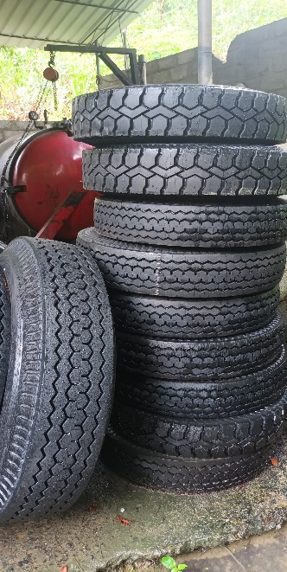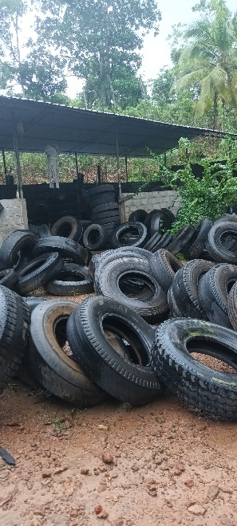**Contact Details**

**Name**

Ryak Tyre House

**Address**

Ryak Tyre House,

Madaviyangoda,

Yatiyana,

Matara.

**Phone Number**

Tel: 0714700023

Figure 0‑2 Ryak Tyre House

Figure 0‑3 Ryak Tyre House

## **1.2. Business Process**

**Roles and Processes in the Current Manual System at the Tire Retreading Center**

The tire retreading center currently operates with a manual system for managing its business processes. The primary roles involved are **owner**, **workers**, and **customers**. The existing manual approach has several limitations, including time-consuming tasks, increased risk of errors, and challenges in tracking operations effectively.

**1. Owner:**

* As the main manager and decision-maker, the owner is responsible for overseeing all aspects of the business. The owner manually manages customer orders, assigns tasks to technicians, monitors inventory levels, and tracks financial transactions.
* All records, including order details, task assignments, and financial reports, are maintained on paper.

**2. Workers:**

* Technicians receive job orders directly from the owner or manager. They manually track material usage, record the status of each job on paper, and update the owner about the progress of repairs.

**3. Customers:**

* Customers interact with the retreading center manually, either by visiting in person or making phone calls to request services. They fill out physical forms to submit their tire repair or retreading requests.
* Customers often call or visit the center for updates on the status of their service. There is no centralized system to track order progress,.
* Payments are made in cash, and receipts are issued manually. Customers must keep physical copies of invoices.

**Service Receipt**

A document is provided to customers upon the completion of tyre repair or retreading services. It serves as a formal record of the service provided, including details such as service type, serialNo, total cost, and Description.

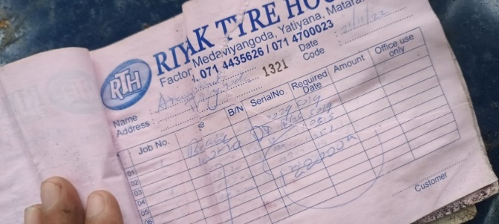

Figure 0‑4 Service Receipt

## **1.3. Problem Definition**

Tyre Repair and Retreading house addresses multiple challenges that currently hinder operational efficiency and customer satisfaction in the industry:

1. **Communication Problems**: There is not a good communications system and the customers are struggling to get rea time updates and also if the owner is not there they have to waste time.
2. **Paper-based Transactions**: The reliance on paper for recording transactions, customer orders, and job progress is inefficient and they can to damage or loss. Paper-based records are also difficult to retrieve quickly making it harder to respond quickly .
3. **Transportation Management**: Without an automated system, delivery becomes challenging.
4. **Customer’s Waiting Time**: Due to manual processes and poor communication, customers often experience extended waiting times, whether for service updates, order placement, or pick-up/delivery. This inefficiency can lead to customer dissatisfaction, impacting repeat business and referrals.
5. **Inventory Management**: Maintaining stock levels for materials such as rubber, adhesives, and other repair items is essential but challenging to manage manually. This often results in overstocking or stockouts,
6. **Data Inaccuracy**: Manually entered records can make errors, which can lead to inaccurate data regarding inventory, customer orders, and repair details.
7. **Manual Work Distribution**: Without an automated system for assigning tasks, work distribution among employees is inefficient, often resulting in unbalanced workloads, delays in completing jobs, overwork some employees while and reduce overall productivity.
8. **Human Errors**: Manual processes, from data entry to job allocation, can cause to human errors. These errors can lead to inaccuracies in billing, job tracking, inventory levels, and customer communications.
9. **Limited Reporting and Analysis**: Paper records make it difficult to perform data analysis on customer orders, material usage, employee productivity, or revenue trends. The inability to generate comprehensive reports and insights limits the business’s capacity to make data-driven decisions.

Addressing these issues through a centralized, automated system would streamline operations, minimize errors, and improve service quality, ultimately enhancing efficiency, accuracy, and customer satisfaction across all aspects of tyre repair and retreading operations.

## **1.4. Aims and Objectives**

The primary aim of the **Tyre Repair and Retreading Management System** is to transition the manual, paper-based processes currently in place at tyre repair and retreading businesses into an efficient, automated system. This will improve the overall operational efficiency, customer satisfaction, and accuracy in managing key tasks such as inventory control, order management, and employee assignments.

**Key Objectives:**

1. **Automation of Customer Orders and Service Requests**:
   * Streamline the process of receiving, processing, and tracking customer orders for tyre repairs and retreading. This will reduce the manual effort involved and minimize errors, ensuring faster service delivery and improved customer experience.
2. **Efficient Inventory Management**:
   * Implement real-time tracking of tyre materials and repair components, ensuring accurate inventory records. The system will help prevent overstocking or stockouts, reduce material wastage, and optimize supply chain management.
3. **Optimized Work Allocation and Scheduling**:
   * Automate the task distribution for repair teams, ensuring that work assignments are balanced, deadlines are met, and resources are used effectively. This objective aims to increase overall employee productivity and streamline job scheduling.
4. **Improved Communication Across Teams**:
   * Establish a centralized communication platform to connect owner, workers, and customers. This will facilitate smoother coordination between them, improve task visibility, and allow for quicker response times to customer queries or issues.
5. **Data Accuracy and Reporting**:
   * Replace manual record-keeping with a digital system that ensures accurate data entry and storage. The system will provide reliable data for generating comprehensive reports on job statuses, financial transactions, and performance metrics.
6. **Reduction of Waiting Times**:
   * Enhance the efficiency of customer service by reducing waiting times for order processing, tyre collection, and delivery. Customers will be able to track the status of their orders in real-time, improving satisfaction and trust in the service.
7. **Human Error Reduction**:
   * Minimize the risk of human errors in inventory management, job scheduling, and financial transactions. By automating routine tasks and implementing validation checks, the system will improve overall accuracy and reliability in business operations.
8. **Scalability and Future Integration**:
   * Design a scalable solution that can grow with the business. The system will allow for future integration with additional features such as customer loyalty programs, online payments, and automated maintenance reminders, helping the business adapt to changing market needs.

## **1.5. Scope of the Project**

The scope of the **Tyre Repair and Retreading Management System** defines the key areas and features that will be addressed by the project, along with the limitations and boundaries to ensure clear project objectives and deliverables. The system will focus on streamlining operations within the tyre repair and retreading process, enhancing customer experience, improving inventory control, and optimizing work processes.

## **1.6. Project Feasibility**

**Technical Feasibility**

The existing infrastructure at the tyre repair facility supports the implementation of the proposed system. Given that employees have basic computer skills, training in system operations will be manageable. The required software and hardware components are accessible and compatible with the facility's current setup, ensuring a smooth transition. Data security measures, such as restricted access and encryption, will safeguard customer and business data. To maintain long-term technical viability, a dedicated maintenance plan can be established to handle system support and updates.

**Economic Feasibility**

A detailed cost analysis will assess the project's financial needs, including expenses for software, hardware, development, and training. The system is expected to reduce manual labor costs and streamline operations, providing a positive return on investment over time. Risk analysis will identify potential budget constraints and strategies for cost control, ensuring the project remains within financial limits.

**Legal Feasibility**

The system will comply with industry standards, ensuring secure handling of customer and transaction data. Necessary legal approvals and adherence to privacy regulations will be obtained to protect all stakeholders. Compliance measures will be built into the system to maintain data security and regulatory alignment.

## **1.7. Summary**

The existing features and nature of the current process were thoroughly analyzed, helping to identify specific issues and areas for improvement. This assessment clarified the project goals and established a well-defined scope and boundaries for the system. The feasibility study further validated that the project is achievable and beneficial within the given constraints.

# **CHAPTER 2 – SYSTEM ANALYSIS**

This chapter presents an analysis of the current system and identifies the proposed system as the optimal solution through Object-Oriented Systems Analysis and Design. It provides a comprehensive system requirement specification, along with use case diagrams, use case descriptions, and activity diagrams for each identified function. Additionally, it outlines various Business System Options (BSOs) considered during development and includes a justification for selecting the most effective BSO as the preferred solution.

**Outline of the Chapter**

• 2.1 Use Case Diagrams for Existing System

• 2.2 Use Case Descriptions for Existing System

• 2.3 Activity Diagrams to describe the functionality of the Use-Cases

• 2.4 System Requirement Specification (SRS)

• 2.5 Complete Business System Options (BSOs)

• 2.6 Selected BSO with Justification

• 2.7 Summary

# **2.1 Use Case Diagram for the Existing System**

The use case diagram provides an overview of the primary processes in the existing Tyre retreading and repair management system. It illustrates the interactions between three key actors: the Owner, Customer, and Worker. The Owner manages the end-to-end service workflow, including creating invoices, processing payments, inspecting tyres, assigning tasks to workers, and recording service details. Customers initiate service requests and make payments, while Workers perform the assigned services. This diagram captures the essential functions and responsibilities, offering a clear, high-level understanding of the operational steps required to manage customer service efficiently in the tyre shop.

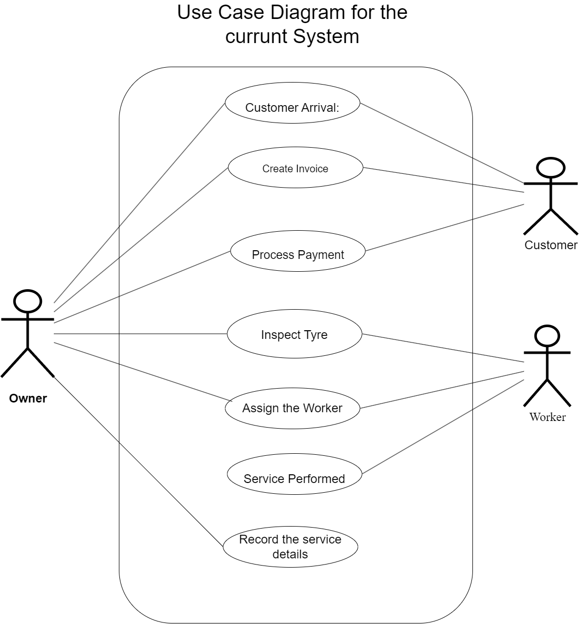

Figure 0‑1 Use Case Diagram for the Existing System

## **2.2 Use Case Description for Existing System**

The existing system streamlines operations at the tire repair and retreading center by managing customer arrivals, invoicing, payments, tire inspections, worker assignments, and service records. It allows the owner to document requirements, generate invoices, process payments, assign skilled workers, and maintain accurate service records. This organized approach enhances efficiency and customer satisfaction through clear communication and timely updates.

### **2.2.1 Use case Description for Customer Arrival**

|  |  |
| --- | --- |
| Use Case ID | UC_001 |
| Use Case Name | Customer Arrival |
| Actors | Customer, Owner |
| Precondition | The customer arrives at the service center with a requirement. |
| Main Flow | 1. Customer arrives and requests a service. 2. Owner interacts with the customer to understand their needs for tire repair, inspection, or retreading. |
| Alternative Flow | * If the customer’s requirement is unclear, the owner provides additional information or a consultation. |
| Postcondition | Customer’s requirements are identified and documented for further processing. |

Table 1 Use case Description for Customer Arrival

### **2.2.2 Use case Description for Create Invoice**

|  |  |
| --- | --- |
| Use Case ID | UC_002 |
| Use Case Name | Create Invoice |
| Actors | Owner, Customer |
| Precondition | Customer service requirements are identified. |
| Main Flow | 1. Owner generates an invoice based on the customer’s requested services. 2. The invoice is presented to the customer for review. |
| Alternative Flow | * If the customer requests changes to the services, the owner modifies the invoice accordingly. * If the invoicing system is down, the owner may issue a manual invoice. |
| Postcondition | An invoice is generated and presented to the customer. |

Table 2 Use case Description for Create Invoice

### **2.2.3 Use case Description for Process Payment**

|  |  |
| --- | --- |
| Use Case ID | UC_003 |
| Use Case Name | Process Payment |
| Actors | Owner, Customer |
| Precondition | An invoice has been created and presented to the customer. |
| Main Flow | 1. Customer reviews the invoice. 2. The owner processes the payment using the chosen payment method. |
| Alternative Flow | * If the customer does not have sufficient funds or the preferred payment is unavailable, the owner discusses alternative options or a payment plan. * If the payment system is down, the owner may accept cash or defer payment until service completion. |
| Postcondition | Payment is successfully processed or recorded for later collection. |

Table 3 Use case Description for Process Payment

### **2.2.4 Use case Description for Inspect Tire**

|  |  |
| --- | --- |
| Use Case ID | UC_004 |
| Use Case Name | Inspect Tire |
| Actors | Owner, Worker |
| Precondition | The customer has explained their service requirements. |
| Main Flow | The owner or assigned worker inspects the customer’s tire to assess the condition.  The tire’s condition is recorded for further action. |
| Alternative Flow | * If the tire is beyond repair, the owner advises the customer to consider purchasing a new tire. * If additional issues are identified during an inspection, the service request may be updated. |
| Postcondition | Tire condition is assessed, and the customer is informed of the recommended service. |

Table 4 Use case Description for Inspect Tire

### **2.2.5 Use case Description for Assign the Worker**

|  |  |
| --- | --- |
| Use Case ID | UC_005 |
| Use Case Name | Assign the Worker |
| Actors | Owner, Worker |
| Precondition | Tire inspection is complete, and necessary work is identified. |
| Main Flow | 1. The owner assigns a worker to perform the required service (repair or retreading). 2. Worker prepares to begin the assigned service. |
| Alternative Flow | * If no worker is available, the owner may schedule the service for a later time or date. * If the assigned worker does not have the required expertise, the owner assigns a different worker. |
| Postcondition | A skilled worker is assigned, or the service is scheduled for completion. |

Table 5 Use case Description for Assign the Worker

### **2.2.5 Use case Description for Service Performed**

|  |  |
| --- | --- |
| Use Case ID | UC_006 |
| Use Case Name | Service Performed |
| Actors | Worker |
| Precondition | The worker has been assigned to perform the service. |
| Main Flow | 1. The worker performs the tyre repair or retreading as specified. 2. Once completed, the tyre is prepared for customer pickup. |
| Alternative Flow | * If unexpected issues arise (e.g., parts unavailable), the worker pauses the service and informs the owner. * If equipment malfunctions, the service is rescheduled or transferred to a different worker. |
| Postcondition | Service is completed, and the tire is ready for handover. |

Table 6 Use case Description for Service Performed

### **2.2.6 Use case Description to Record the Service Details**

|  |  |
| --- | --- |
| Use Case ID | US_007 |
| Use Case Name | Record the Service Details |
| Actors | Owner |
| Precondition | Service has been completed. |
| Main Flow | 1. The owner records service details, including customer information, type of service, and charges. 2. The service record is saved in the system for future reference. |
| Alternative Flow | * If the record-keeping system is unavailable, the owner records details manually or in a temporary log. * If additional services were provided that were not invoiced, the record is updated, and the customer is notified. |
| Postcondition | Service details are recorded and saved in the system. |

Table 7 Use case Description to Record the Service Details

## **2.3 Activity diagrams for the current business process**

### **2.3.1 Customer Arrival and Service – Activity Diagram**

The activity diagram describes the functionality of the Customer Arrival and Service Process identified in the use case diagrams of the current manual system.

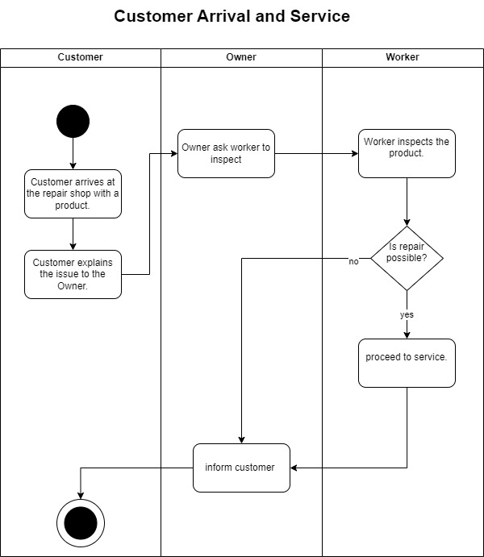

Figure 0‑1 Customer Arrival and Service – Activity Diagram

### **2.3.2 Inventory Management – Activity Diagram**

The activity diagram describes the functionality of the Inventory Management Process identified in the use case diagrams of the current manual system.

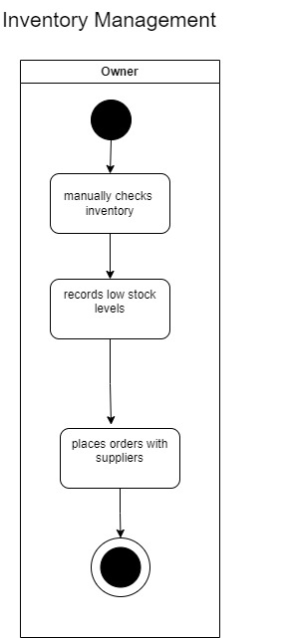

Figure 0‑2 Inventory Management – Activity Diagram

### **2.3.3 Manual Inventory Tracking – Activity Diagram**

The activity diagram describes the functionality of the Manual Inventory Tracking Process identified in the use case diagrams of the current manual system.

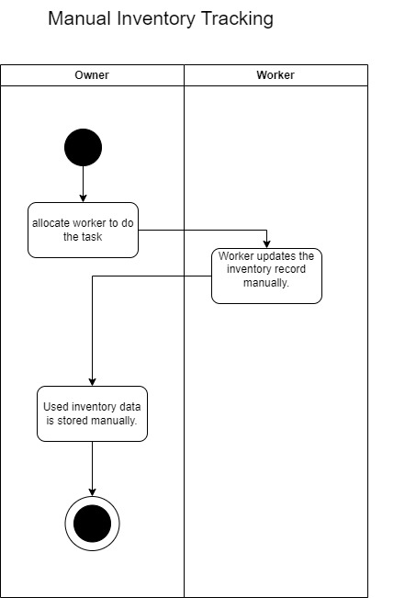

Figure 0‑3 Manual Inventory Tracking – Activity Diagram

### **2.3.4 Payment & Invoice Generation – Activity Diagram**

The activity diagram describes the functionality of the Payment & Invoice Generation Process identified in the use case diagrams of the current manual system.

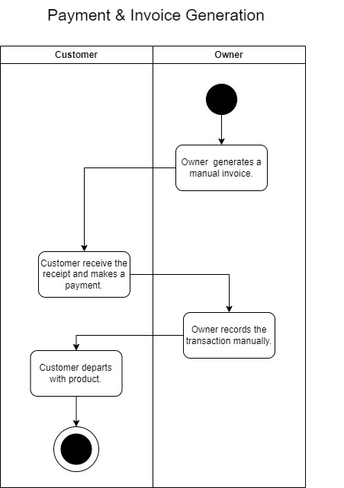

Figure 0‑1 Payment & Invoice Generation – Activity Diagram

# **2.4 System Requirement Specification (SRS)**

The System Requirements Specification (SRS) for the Tire Repair and Retreading Management System outlines the essential details of the system, covering both functional and non-functional requirements. It defines user expectations, such as customer management, service tracking, invoicing, and worker assignments, as well as system constraints and performance standards. Acting as a key document for development, the SRS promotes a clear understanding among stakeholders and provides a structured path for system design and implementation. This detailed guide ensures the system meets industry standards, enhancing operational efficiency and responsiveness to customer needs while supporting a streamlined and well-organized development process.

**System Requirements Summary**

Include:

The order on priority (H-High, M-Moderate, L-Low)

Mandatory or Optional (M/O),

Weight (H- High, M-Moderate, L-Low)

## **2.4.1 User Story List**

User stories are crafted from an end-user perspective to illustrate specific software functions. Each user story identifies the type of user, their desired action, and the purpose behind it, helping to define both functional and non-functional requirements. The following table outlines several user stories, detailing how different types of users interact with the system and the features that support these interactions.

|  |  |
| --- | --- |
| ID | User Stories |
| US-01 | As a customer, I want to register, create an account and place an order by selecting the service type and uploading images of my tyres, so that the owner can assess them for repair. |
| US-02 | As a customer, I want to view the status of my order and be notified when my order is accepted, denied and ready in real, so I can track its progress without calling or visiting the shop. |
| US-03 | As a customer, I want to pay for my completed order in the shop and receive a printed receipt for my records. |
| US-04 | As a customer, I want to leave a review after my order is completed and view my order history to provide feedback on the service quality. |
| US-05 | As the owner, I want to view all newly submitted orders, including details and images, and accept or reject them based on my assessment, I want to notify customers of rejected orders, including the reason so that I can assess whether each Tyre can be repaired |
| US-06 | As the owner, I want to view each worker’s workload, assign repair jobs to workers and self-assign orders, if necessary, based on their availability, so that orders can be processed efficiently. |
| US-07 | As the owner, I want to update the system with payment details when a customer pays and generate a receipt after payment is made so I can keep an accurate record of completed transactions. |
| US-08 | As a worker, I want to receive a notification when a new repair job is assigned to me and update the order status as I complete each repair stage, so the customer and owner can track the repair progress as a worker. |

Figure 0‑1 User story List – Current System

## **2.4.2 Functional requirements**

Functional requirements specify the essential tasks and behaviors that the Tire Repair and Retreading Management System must fulfill to meet user needs. They define actions for each type of user and the expected responses from the system, guiding the development process from design to implementation and testing. These requirements ensure the system delivers on both user expectations and business objectives, resulting in an efficient, user-friendly platform for managing tire services.

|  |  |  |  |
| --- | --- | --- | --- |
| Requirement | Priority  H/M/L | M/O | Weight  H/M/L |
| * The system **shall** allow new customers to register by entering the required personal information and creating a secure password. | H | M | H |
| * The system **shall** enable registered users to log in and manage their account information. | H | M | H |
| * The system **shall** allow registered customers to create new orders by selecting the service type and providing details of the tires. | H | M | H |
| * The system **shall** enable customers to upload images of the tires when place an order. | M | M | H |
| * The owner **shall** have the ability to view all newly submitted orders, including uploaded images and selected service types. | H | M | H |
| * The system **shall** allow the owner to accept or reject each order based on an assessment of the tire's condition. | H | M | H |
| * If an order is rejected, the system **shall** notify the customer and record the reason for rejection and rejected orders **shall** not be added to the active work queue. | H | M | H |
| * The system **shall** allow the owner to view each worker’s workload and assign accepted orders accordingly. | M | M | H |
| * The system **shall** allow the owner to self-assign orders if necessary. | L | M | H |
| * Assigned workers **shall** be able to update the order status to reflect the current stage of repair. | M | M | H |

|  |  |  |  |
| --- | --- | --- | --- |
| * The system **shall** provide real-time status updates visible to customers. | H | M | H |
| * The system **shall** allow customers to leave feedback or ratings on completed orders to improve service quality. | M | M | H |
| * The system **shall** allow customers to view a history of their past orders | L | M | H |
| * Workers **should** receive a notification when a new order is assigned to them. | M | M | H |
| * The system **should** notify workers of any pending updates or order assignments. | M | M | H |
| * Upon completion of repairs, the system **shall** notify the customer that the order is ready for pickup and payment. | H | M | H |
| * The system **shall** allow the owner to record payment details upon customer payment | H | M | H |
| * The system **shall** generate a receipt for the completed order and provide a printed copy. | M | M | H |
| * The customer **should** receive a digital copy of the receipt in their account or via email. | M | M | H |

Table 8 Functional Requirement

## **2.4.3 Non-functional requirements**

Non-functional requirements are essential for defining the system's performance, security, and usability standards for the Tire Repair and Retreading Management System. These requirements, when measurable, establish benchmarks for evaluating attributes like response time, reliability, and scalability. Meeting these criteria ensures a robust, efficient, and user-friendly system that aligns with industry standards.

|  |  |  |  |
| --- | --- | --- | --- |
| Non-Functional Requirements | Priority | M/O | Weight |
| * The system **shall** have an intuitive and user-friendly interface for the users. | H | M | H |
| * The system **shall** be mobile-responsive to allow access on various devices, including smartphones and tablets. | H | M | H |
| * The system **shall** handle multiple users simultaneously without significant delays. | H | M | H |
| * Status updates, notifications, and payment processing **should** be real-time. | H | M | H |
| * The system **shall** maintain high availability, with minimal downtime | H | M | H |
| * The system **shall** use encryption to protect customer data, including passwords. | H | M | H |
| * Role-based access control **shall** be implemented, ensuring sensitive actions (e.g., order assignment, payment updates) are restricted to authorized users. | H | M | H |
| * The system **shall** validate all data entered by users, ensuring accuracy. | H | M | H |

Table 9 Non-functional requirements

## **2.5 Complete Business System Options (BSOs)**

### **2.5.1 BSO 1: Cloud-Based Web Application**

Choosing a cloud-based web application for the Tire Repair and Retreading Management System offers a modern, flexible solution that aligns with Eko Plasco’s objectives. Utilizing third-party cloud providers ensures scalability, enhanced accessibility, and security features with a pay-as-you-go model, which is cost-efficient and adaptable to growing business needs.

**Benefits:**

* **Low upfront cost**: Eliminates the need for investments in hardware or software licenses.
* **Scalability**: Cloud providers offer flexible scaling options to meet demand, preventing infrastructure constraints.
* **Accessibility**: Accessible from anywhere, supporting remote work and providing user convenience.
* **Automatic updates and maintenance**: Cloud providers manage updates and maintenance, reducing the load on internal IT resources.
* **Security**: Cloud providers usually have robust, built-in security infrastructure to protect data.

**Issues:**

* **Subscription fees**: Recurring costs may exceed on-premises costs over time.
* **Data security concerns**: Relying on third-party providers may introduce privacy and security risks.
* **Dependence on internet connectivity**: Accessibility may be disrupted during internet outages.

### **2.5.2 BSO 2: On-Premises Software Solution**

An on-premises software solution involves installing and maintaining the Tire Repair and Retreading Management System on local servers. This option provides complete control over the system, including data management, security, and infrastructure, while also eliminating ongoing subscription fees.

**Benefits:**

* **Complete control:** Full control over the system, data, and security measures.
* **Data security:** Sensitive data is stored on-premises, reducing concerns about third-party access or breaches.
* **No ongoing subscription fees:** One-time purchase and maintenance costs instead of recurring cloud fees.
* **Customizability:** On-premises solutions can be tailored to specific business needs, allowing for more flexibility in features.

**Issues:**

* **High initial cost:** Significant upfront investment in hardware, software, and IT infrastructure.
* **Maintenance burden:** Requires internal IT staff for system maintenance, updates, and troubleshooting.
* **Limited scalability:** Scaling may require purchasing additional hardware, which can be costly and time-consuming.
* **Access limitations:** Remote access may be more difficult compared to a cloud solution and may require complex VPN setups.

### **2.5.3 BSO 3: Hybrid Cloud Solution**

A hybrid cloud solution integrates both on-premises and cloud-based systems. This option enables businesses to keep sensitive data on-site while leveraging cloud computing for other functions such as data storage, backup, and scalability.

**Benefits:**

* **Flexibility:** Can optimize the strengths of both cloud and on-premises solutions for different business needs.
* **Cost-effective scalability:** Allows for scaling certain operations through the cloud, reducing infrastructure costs.
* **Data security:** Sensitive data can be kept on-premises, reducing concerns about third-party access while still utilizing cloud benefits for non-sensitive data.
* **Business continuity:** Cloud backup and disaster recovery options ensure data protection and minimize downtime.

**Issues:**

* **Complex integration:** Integrating on-premises systems with cloud-based services can be challenging and require specialized expertise.
* **Higher costs:** May require investment in both on-premises infrastructure and cloud services, leading to higher overall costs.
* **Management complexity:** Requires monitoring and managing both on-premises and cloud environments, which can increase administrative overhead.

### **2.5.4 BSO 4: Local Software Application with Off-Site Backups**

This solution involves a locally installed software application with off-site backups to ensure data protection. The software is operated entirely within the business premises, with backup data stored remotely in secure data centers.

**Benefits:**

* **Control and security:** Offers the same control over data and security as on-premises solutions, while still ensuring data is safely backed up off-site.
* **Lower cost:** No need for a large-scale cloud infrastructure, and off-site backups are often less expensive than full cloud solutions.
* **Data protection:** Off-site backups ensure that data is protected in case of hardware failure or other disasters.

**Issues:**

* **Limited scalability:** The system may need to be upgraded to meet growing demands, with additional costs for hardware and software.
* **Dependency on manual management:** Although backups are off-site, the management of backups and recovery processes might still require internal resources.
* **Access limitations:** Remote access is not as seamless as cloud-based solutions, requiring VPNs or other secure connections.

### **2.5.5 BSO 5: SaaS (Software as a Service) Solution**

A Software as a Service (SaaS) solution is a cloud-based application hosted by a third-party provider, where users access the software via the internet. This approach is ideal for businesses looking for a fully managed solution that eliminates the need for internal IT management.

**Benefits:**

* **Cost-effective:** Typically available through subscription models, SaaS eliminates large upfront costs and offers predictable pricing.
* **Fast deployment:** SaaS solutions are ready to use immediately, requiring minimal setup or configuration.
* **Automatic updates:** The provider handles all updates, ensuring the system remains up-to-date with the latest features and security patches.
* **Accessibility:** Accessible from anywhere with an internet connection, supporting remote work.

**Issues:**

* **Limited customization:** SaaS solutions may not be as customizable as on-premises or hybrid solutions, limiting business-specific features.
* **Data privacy concerns:** Businesses may be concerned about storing sensitive data with third-party providers, depending on the SaaS provider’s security practices.
* **Internet reliance:** Accessibility is dependent on internet connectivity, and service disruptions can affect business operations.

## **2.6 Selected BSO with Justification**

Based on the comparison, BSO 1 (Cloud-Based Web Application) seems like the most suitable

option for your needs due to several factors:

• Cost-effectiveness:

No upfront investments, predictable subscription fees.

• Scalability:

Adapts to growth easily and efficiently without infrastructure limitations.

• Accessibility:

Users can access it from anywhere, anytime, enhancing flexibility.

• Reduced IT burden:

Cloud provider handles updates and maintenance, freeing your team.

• Potential for faster innovation:

Cloud providers often release new features quickly.

## **2.7 Summary**

This chapter reviewed the current features of the process, leading to the identification of both functional and nonfunctional requirements. Based on the analysis of Business System Options (BSOs), the best solution was chosen: developing a Decision Support System (DSS) for Logistics Management. This system will support Strategic and Operational Decision Making by leveraging statistical algorithms to enhance decision-making capabilities in logistics.

# **CHAPTER 3 – SYSTEM DESIGN**

This chapter provides a comprehensive view of the proposed system design, detailing the specifications established in Chapter 2 through various models and diagrams. It includes Use Case Diagrams and descriptions to illustrate system interactions, Activity Diagrams to map process flows, and Entity-Relationship Diagrams to outline data structure. Additionally, it presents Entity Class, Controller Class, and Interface Class Diagrams, along with Sequence Diagrams that capture interaction sequences within the system. The chapter concludes with a normalized database design for efficient data management, database specifications, and wireframes for the user interfaces, collectively forming the system’s foundational blueprint.

**Outline of the chapter**

3.1 Use case diagrams for the proposed system

3.2 Use case descriptions for the proposed system

3.3 Activity diagrams for the proposed system

3.4 Class diagrams for the proposed system

3.5 Sequence diagram for the proposed system

3.6 Normalized Database Design

3.7 User Interface Designs for the proposed system

3.8 Summary

## **3.1 Use Case diagram for the proposed system**

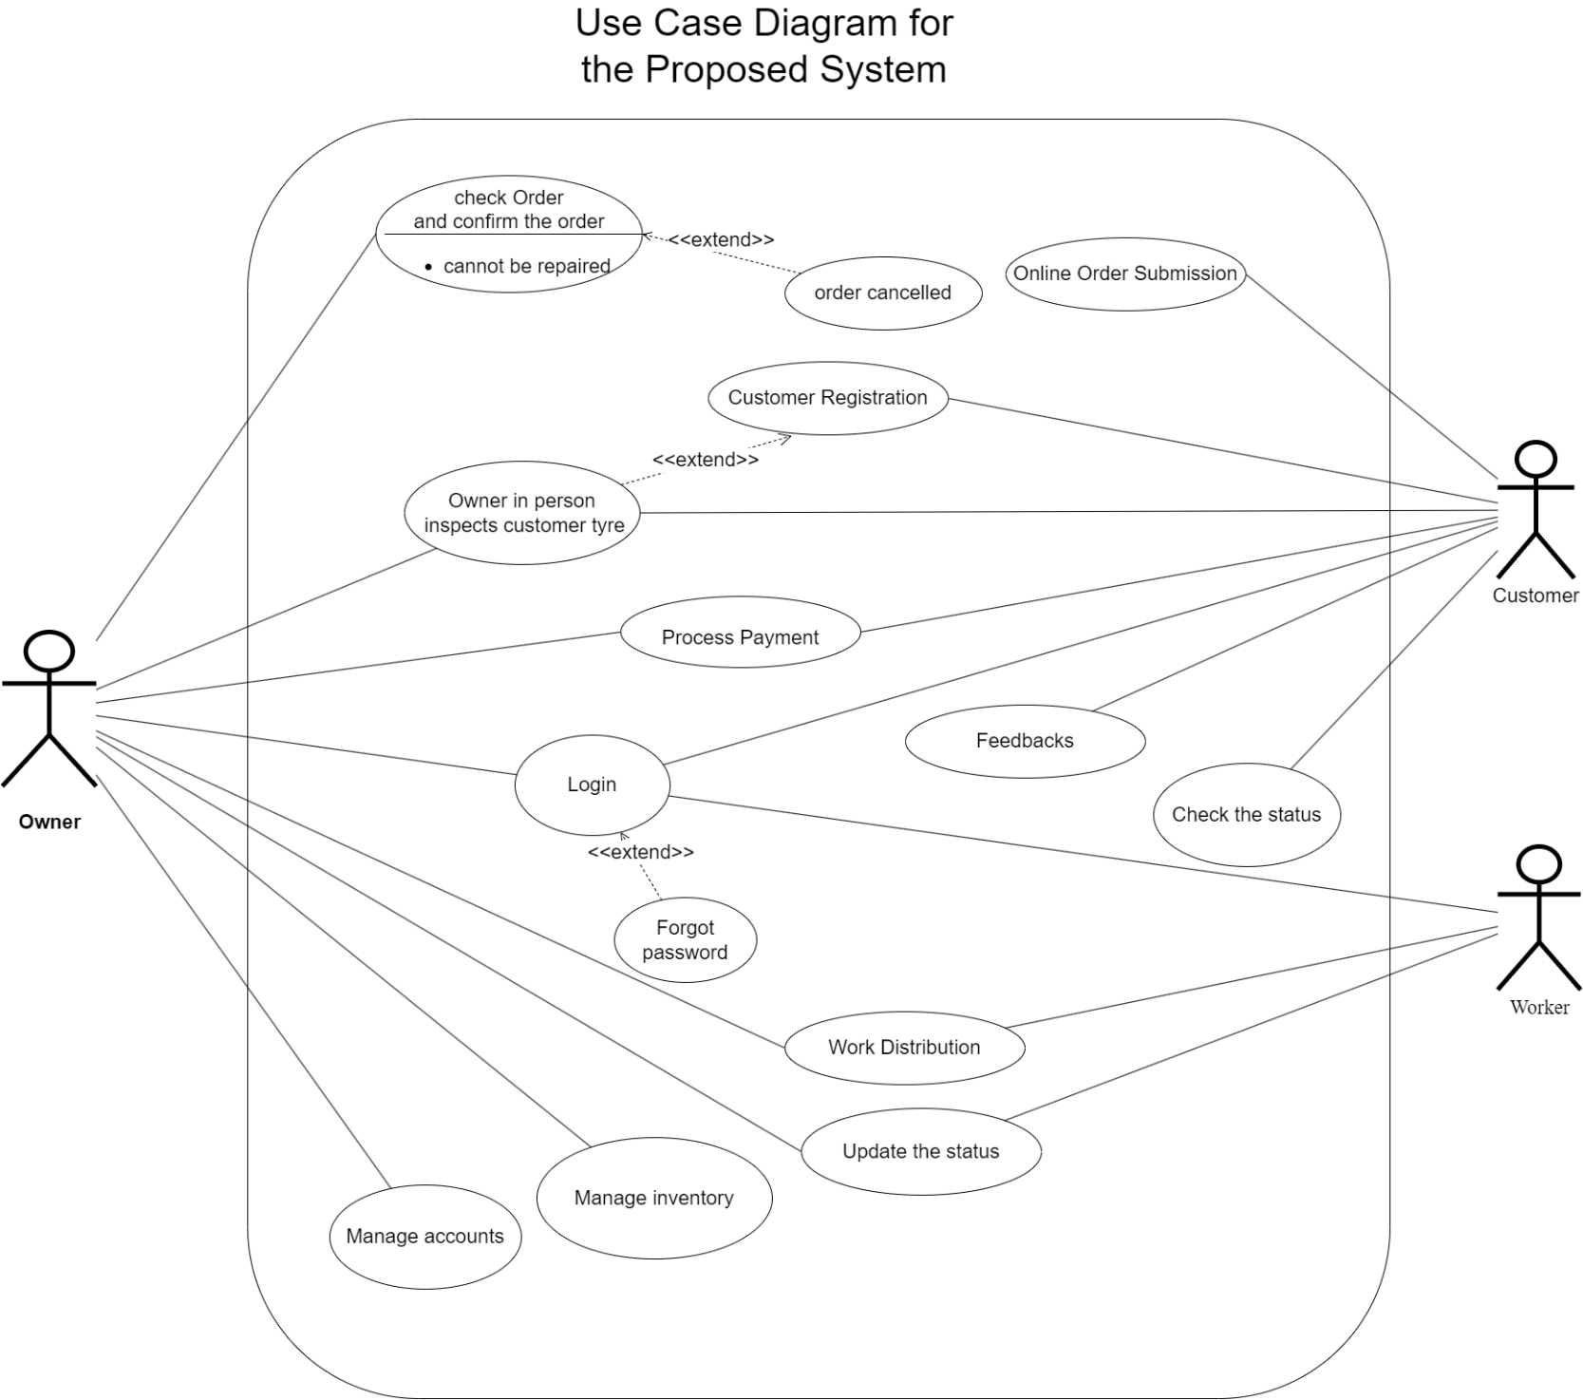The Use Case Diagram for the proposed system is a vital tool that visually represents the system's functionalities and user interactions. It outlines various user roles, their actions, and how the system responds, providing clarity on the system's scope and requirements. In the **Software Development Life Cycle (SDLC)**, the Use Case Diagram acts as a blueprint that guides developers by ensuring alignment between user needs and system functionality. It facilitates better communication among stakeholders, mitigates misinterpretations, and helps in creating a user-centric system. This diagram ensures that the system is developed with a clear understanding of user expectations, contributing to a more efficient and effective development process.

Figure 0‑1 Use Case diagram for the proposed system

## **3.2 Use case identified for the Proposed System**

### **3.2.1 Use case Description for Customer Registration**

|  |  |
| --- | --- |
| Use Case ID | UP_001 |
| Use Case Name | Customer Registration |
| Actors | Customer |
| Precondition | The customer wants to create an account in the system. |
| Main Flow | 1. Customer enters personal details and submits the registration form. 2. The system verifies the information and creates an account. |
| Alternative Flow | * If the information is incomplete or incorrect, the system prompts the customer to re-enter the details. |
| Postcondition | The customer account is successfully created. |

Table 10 Use case Description for Customer Registration

### **3.2.2 Use case Description for Login**

|  |  |
| --- | --- |
| Use Case ID | UP_002 |
| Use Case Name | Login |
| Actors | Customer, Owner, Worker |
| Precondition | User must have registered in the system. |
| Main Flow | User enters username and password.  System verifies the credentials and grants access if valid. |
| Alternative Flow | * If login credentials are incorrect, the system displays an error message and prompts for re-entry. * If the user forgets their password, they can use the “Forgot Password” option. |
| Postcondition | User successfully logs in to the system |

Table 11 Use case Description for Login

### **3.2.3 Use case Description for Forgot Password**

|  |  |
| --- | --- |
| Use Case ID | UP_003 |
| Use Case Name | Forgot Password |
| Actors | Customer, Owner, Worker |
| Precondition | User is unable to remember their password. |
| Main Flow | 1. User selects “Forgot Password” option. 2. System prompts the user to enter their registered email or phone number. 3. System sends a password reset link or code. |
| Alternative Flow | * If the entered email/phone number is unrecognized, the system prompts the user to re-enter it. |
| Postcondition | User receives a reset link or code to reset their password. |

Table 12 Use case Description for Forgot Password

### **3.2.4 Use case Description for Online Order Submission**

|  |  |
| --- | --- |
| Use Case ID | UP_004 |
| Use Case Name | Online Order Submission |
| Actors | Customer |
| Precondition | Customer is logged in and selects a service. |
| Main Flow | • Customer selects desired services and submits an order online.  • System confirms the order and displays an order summary. |
| Alternative Flow | * If there are incomplete details, the system prompts the customer to complete them. |
| Postcondition | Order is submitted and recorded in the system. |

Table 13 Use case Description for Online Order Submission

### **3.2.5 Use case Description for Check Order and Confirm or Cancel the Order**

|  |  |
| --- | --- |
| Use Case ID | UP_005 |
| Use Case Name | Check Order and Confirm or Cancel the Order |
| Actors | Customer |
| Precondition | Customer has submitted an order. |
| Main Flow | • Customer views the submitted order details.  • Customer confirms or cancels the order. |
| Alternative Flow | * If the order cannot be canceled (e.g., due to processing status), the system informs the customer. |
| Postcondition | Order status is updated based on customer action. |

Table 14 Use case Description for Check Order and Confirm or Cancel the Order

### **3.2.6 Use case Description for Process Payment**

|  |  |
| --- | --- |
| Use Case ID | UP_006 |
| Use Case Name | Process Payment |
| Actors | Customer, Owner |
| Precondition | Order is confirmed by the customer. |
| Main Flow | • The customer selects a payment method and submits payment.  • The system processes the payment and confirms the transaction. |
| Alternative Flow | * If payment fails, the system prompts the customer to retry or select a different payment method. |
| Postcondition | Payment is successfully processed and recorded. |

Table 15 Use case Description for Process Payment

### **3.2.7 Use case Description for Work Distribution**

|  |  |
| --- | --- |
| Use Case ID | UP_007 |
| Use Case Name | Work Distribution |
| Actors | Owner, Worker |
| Precondition | The order has been confirmed, and payment is processed. |
| Main Flow | The owner assigns a worker to carry out the service based on order details. The assigned worker receives notification of the task. |
| Alternative Flow | * If no worker is available, the owner may schedule the service for later. |
| Postcondition | The worker is assigned to the task. |

Table 16 Use case Description for Work Distribution

### **3.2.8 Use case Description for Update the Status**

|  |  |
| --- | --- |
| Use Case ID | UP_008 |
| Use Case Name | Update the Status |
| Actors | Owner, Worker |
| Precondition | Work has been assigned to a worker. |
| Main Flow | • The worker or owner updates the status of the service (e.g., In Progress, Completed). |
| Alternative Flow | * If an issue arises, the worker may update the status to indicate a delay. |
| Postcondition | Service status is updated for tracking. |

Table 17 Use case Description for Update the Status

### **3.2.9 Use case Description for Check the Status**

|  |  |
| --- | --- |
| Use Case ID | UP_009 |
| Use Case Name | Check the Status |
| Actors | Customer, Worker |
| Precondition | The customer or worker is logged in to the system. |
| Main Flow | 1. Customer or worker views the current status of the order or task |
| Alternative Flow | * If there is an error retrieving status, the system prompts for a retry.. |
| Postcondition | The customer or worker views the current status of the order. |

Table 18 Use case Description for Check the Status

### **3.2.9 Use case Description for Feedback**

|  |  |
| --- | --- |
| Use Case ID | UP_010 |
| Use Case Name | **Feedback** |
| Actors | Customer |
| Precondition | Service is completed. |
| Main Flow | 1 Customer provides feedback on the service.  2 Feedback is recorded in the system. |
| Alternative Flow | * If feedback submission fails, the system prompts the customer to retry. |
| Postcondition | Feedback is recorded successfully. |

Table 19 Use case Description for Feedback

### **3.2.10 Use case Description for managing inventory**

|  |  |
| --- | --- |
| Use Case ID | UP_011 |
| Use Case Name | **Manage Inventory** |
| Actors | Owner |
| Precondition | The owner is logged in and has access to inventory management. |
| Main Flow | Owner views and updates inventory details as needed.  The system saves the inventory updates. |
| Alternative Flow | * If there is an issue updating inventory, the system displays an error message. |
| Postcondition | Inventory details are updated successfully. |

Table 20 Use case Description for Manage Inventory

### **3.2.11 Use case Description for managing accounts**

|  |  |
| --- | --- |
| Use Case ID | UP_012 |
| Use Case Name | **Manage Accounts** |
| Actors | Owner |
| Precondition | The owner is logged in and has access to account management. |
| Main Flow | Owner views, adds, updates, or removes user accounts.  The system saves account changes. |
| Alternative Flow | If there is an issue saving changes, the system prompts the owner to retry. |
| Postcondition | User accounts are managed successfully |

Table 21 Use case Description for Manage Accounts

### **3.2.12 Use case Description for Inspect Customer Tire**

|  |  |
| --- | --- |
| Use Case ID | UP_013 |
| Use Case Name | **Inspect Customer Tire** |
| Actors | Owner |
| Precondition | The customer has submitted an order with tire inspection as a requirement. |
| Main Flow | 1. The owner inspects the customer’s tire and records findings. |
| Alternative Flow | * If the tire is found to be beyond repair, the owner notifies the customer of alternative options. |
| Postcondition | Tire inspection details are recorded, and the customer is informed of the outcome. |

Table 22 Use case Description for Inspect Customer Tire

## **3.3 Activity Diagrams for the Proposed System**

Activity diagrams model the flow of actions within a system, outlining the sequence of activities in each use case. They highlight specific actions by users and the system, including decision points, pre-conditions, post-conditions, and alternative paths. These diagrams offer a clear visual of system-user interactions, aiding in the design of functional and decision-making processes to align with user needs.

### **3.3.1 Activity Diagram for Place Online Order**

The "Place Online Order" diagram shows the process where a customer accesses the system online, selects a service and places an order. The system then records the order and sends a confirmation back to the customer, completing the transaction. This workflow highlights a streamlined interaction between the customer and the system for efficient order processing.

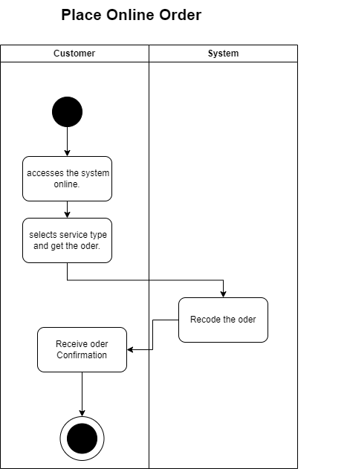

Figure 0‑2 Activity Diagram for Place Online Order

### **3.3.2 Activity Diagram for Work Distribution**

The "Work Distribution" activity begins after order confirmation and payment. The owner reviews the order and checks worker availability. If a worker is available, the owner assigns the task and sends a notification to the worker. If no worker is available, the owner schedules the service for a later time. The process ends once the worker is assigned to the task.

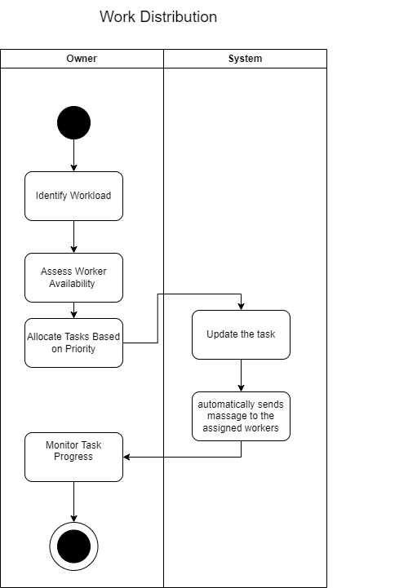

Figure 0‑3 Activity Diagram for Work Distribution

### **3.3.3 Activity Diagram for Update the status**

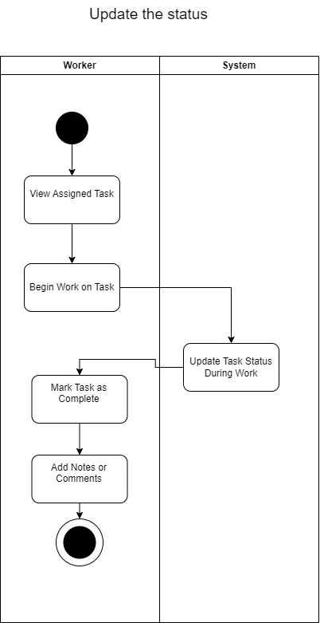The "Update Status" activity diagram illustrates the process of tracking service progress. Once a task is assigned, the worker or owner updates the service status (e.g., In Progress, Completed) as work progresses. If there’s a delay, the worker can set the status to reflect the issue. This ensures that the service status remains up-to-date for effective tracking and management.

Figure 0‑4 Activity Diagram for Update the status

### **3.3.4 Activity Diagram for Payment & Digital Invoice**

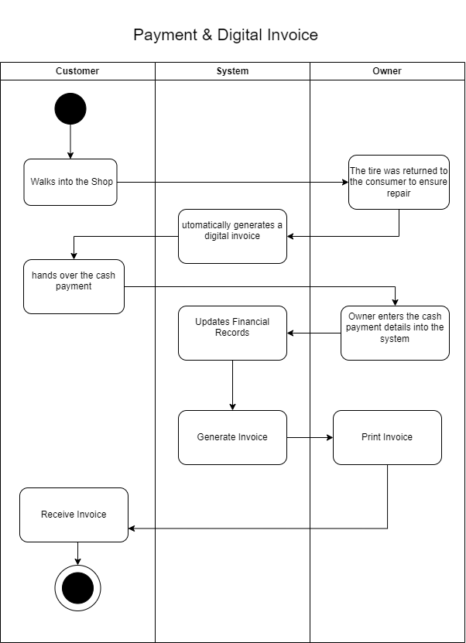The "Payment & Digital Invoice" activity diagram outlines the steps for processing customer payments. After the order is confirmed, the customer selects a payment method and submits the payment. The system then processes and confirms the transaction. If the payment fails, the customer is prompted to retry or choose a different payment option. Upon successful payment, the transaction is recorded, ensuring that payment details are captured and a digital invoice can be generated.

Figure 0‑5 Activity Diagram for Payment & Digital Invoice

### **3.3.5 Activity Diagram for Manage Account**

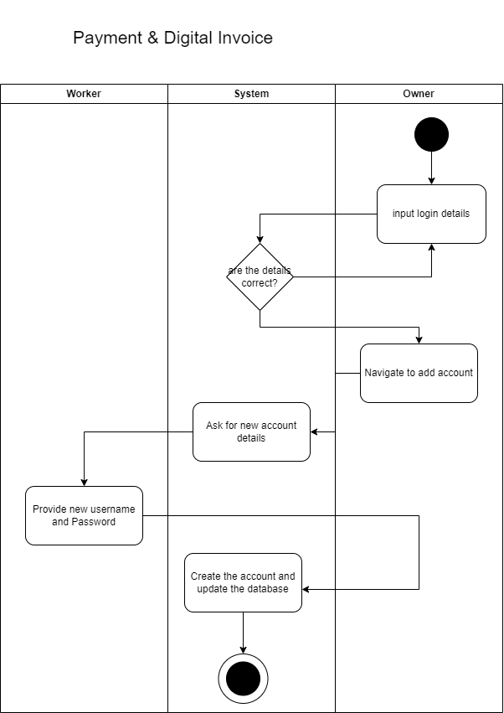 The "Manage Account" activity diagram illustrates the process for managing user accounts. When logged in, the owner can view, add, update, or delete user accounts. After making changes, the system saves the updates. If any issues occur during saving, the system prompts the owner to retry. Once completed, user accounts are successfully managed, ensuring accurate account information within the system.

Figure 0‑6 Activity Diagram for Manage Account

### **3.3.6 Activity Diagram for Manage Account**

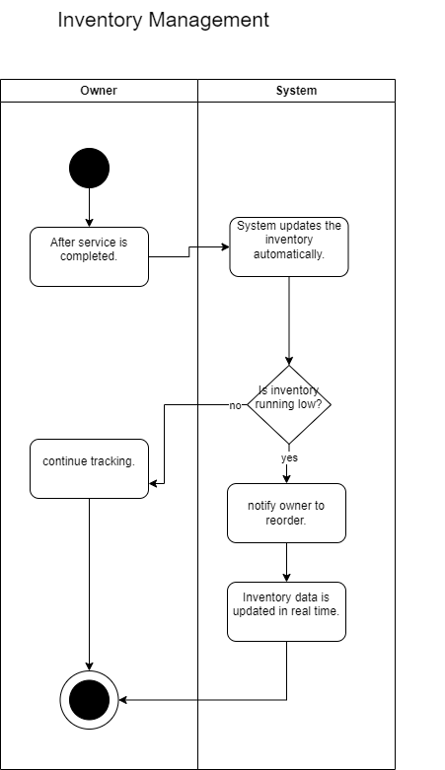The "Manage Account" activity diagram outlines the steps involved in managing an account within the system. It shows how the account holder logs in, views their account details, and makes updates as needed. If the updates are valid, the system saves the changes. In case of errors during the update process, the system displays an error message to the user. The diagram helps visualize these activities, ensuring a smooth account management process.

Figure 0‑7 Activity Diagram for Manage Account

### **3.3.7 Activity Diagram for Owner in person inspects customer Tyre**

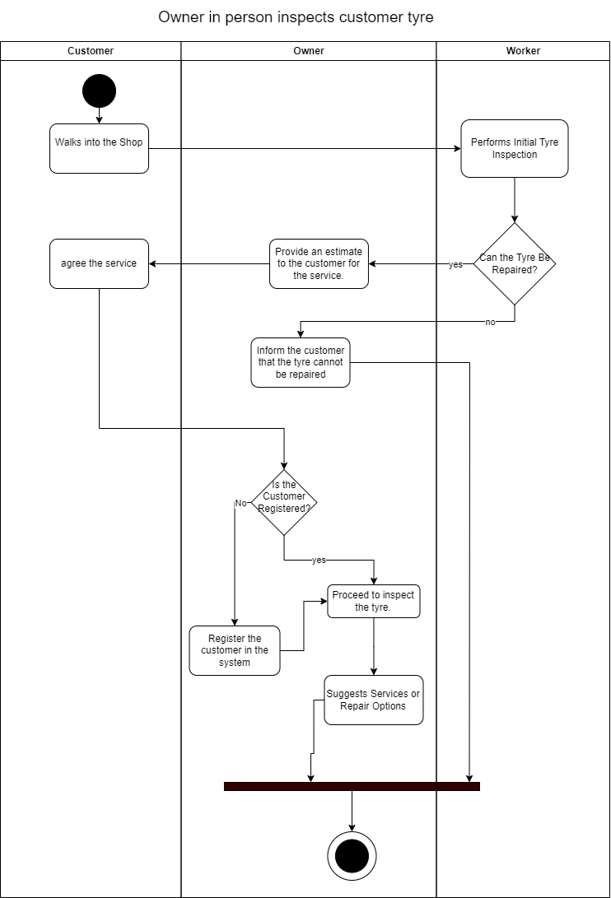The "Owner Inspects Customer's Tire" activity diagram outlines the process the owner follows when inspecting a customer's tire. After receiving an order with tire inspection as a requirement, the owner inspects the tire and records the findings. If the tire is deemed beyond repair, the owner informs the customer of alternative options. The diagram ensures that all necessary steps are followed, with clear actions for both inspection and handling repairs or alternatives.

Figure 0‑8 Activity Diagram for Owner in person inspects customer Tyre

### **3.3.8 Activity Diagram for A diagram of customer feedback Description automatically generatedCustomer Registration**

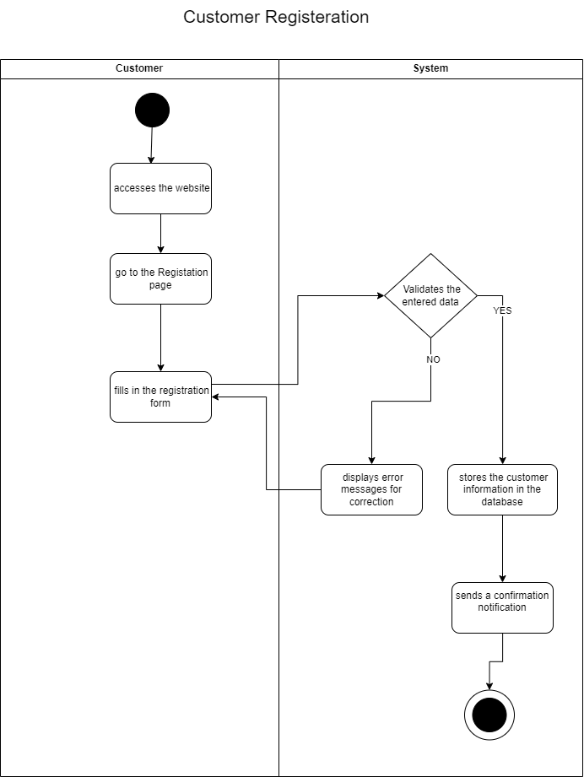The "Customer Registration" activity diagram outlines the process for a customer to create an account in the system. The customer submits their personal details through a registration form, and the system verifies the information before creating the account. If the details are incomplete or incorrect, the system prompts the customer to correct them. Once the information is valid, the account is successfully created. This diagram illustrates the steps involved in ensuring a smooth registration process.

Figure 0‑9 Activity Diagram for Customer Registration

### **3.3.9 Activity Diagram for Check order and confirm the order**

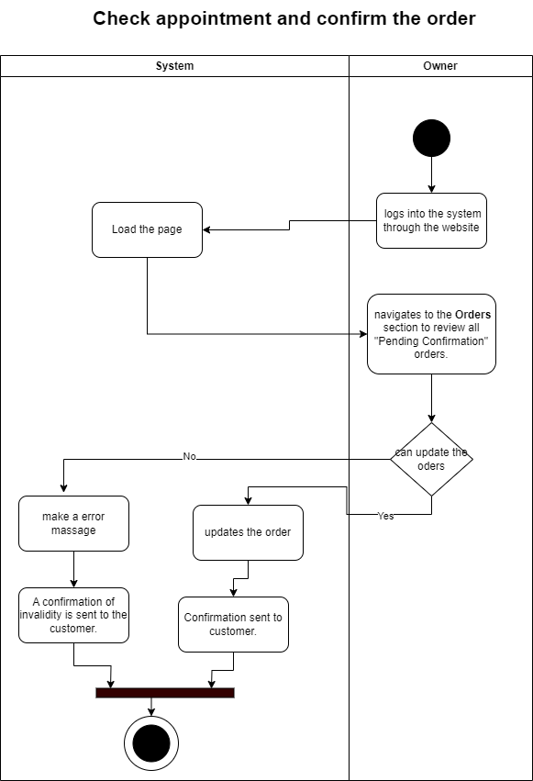The "Check Order and Confirm Order" activity diagram outlines the process a customer follows after submitting an order. The customer views the order details and has the option to either confirm or cancel the order. If cancellation is not possible due to the order’s processing status, the system informs the customer of the restriction. The diagram ensures the order status is updated based on the customer’s decision, either confirming or canceling the order.

Figure 0‑10 Activity Diagram for Check order and confirm the order

### **3.3.10 Activity Diagram for Customer Feedback**

The "Customer Feedback" activity diagram outlines the process for customers to provide feedback after a service is completed. The customer submits their feedback, which is then recorded in the system. If the feedback submission fails, the system prompts the customer to retry. The diagram ensures that the feedback is successfully recorded, allowing the system to capture customer input for further improvements.

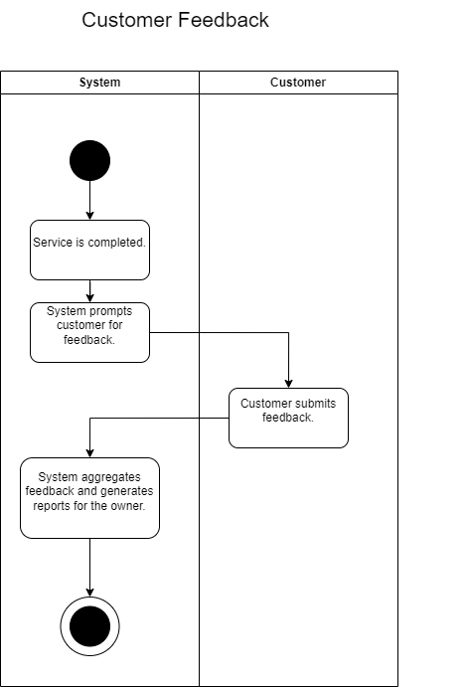

Figure 0‑11 Activity Diagram for Customer Feedback

## **3.4 Class diagrams for the proposed system**

A class diagram in UML represents the static structure of a system by showing its classes, their attributes, methods, and the relationships between them.

### **3.4.1 Entity Class diagram for the proposed system**

The entity class diagram indicates the relationship of entity sets that are going to store in the database of the proposed system.

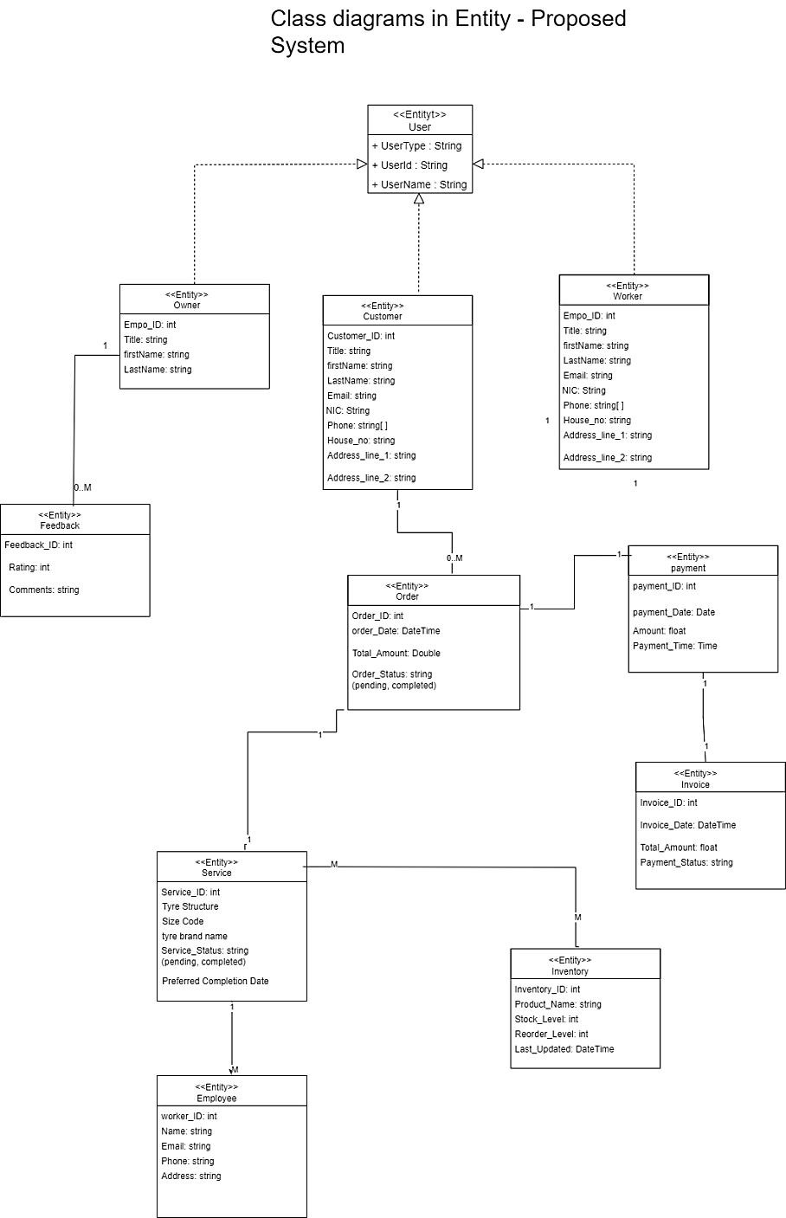

Figure 0‑12 Entity Class diagram for the proposed system

### **3.4.2 Controller Class diagram for the proposed system**

The following diagram shows the controller classes of the proposed system that are associated with the system's interface classes and entity classes.

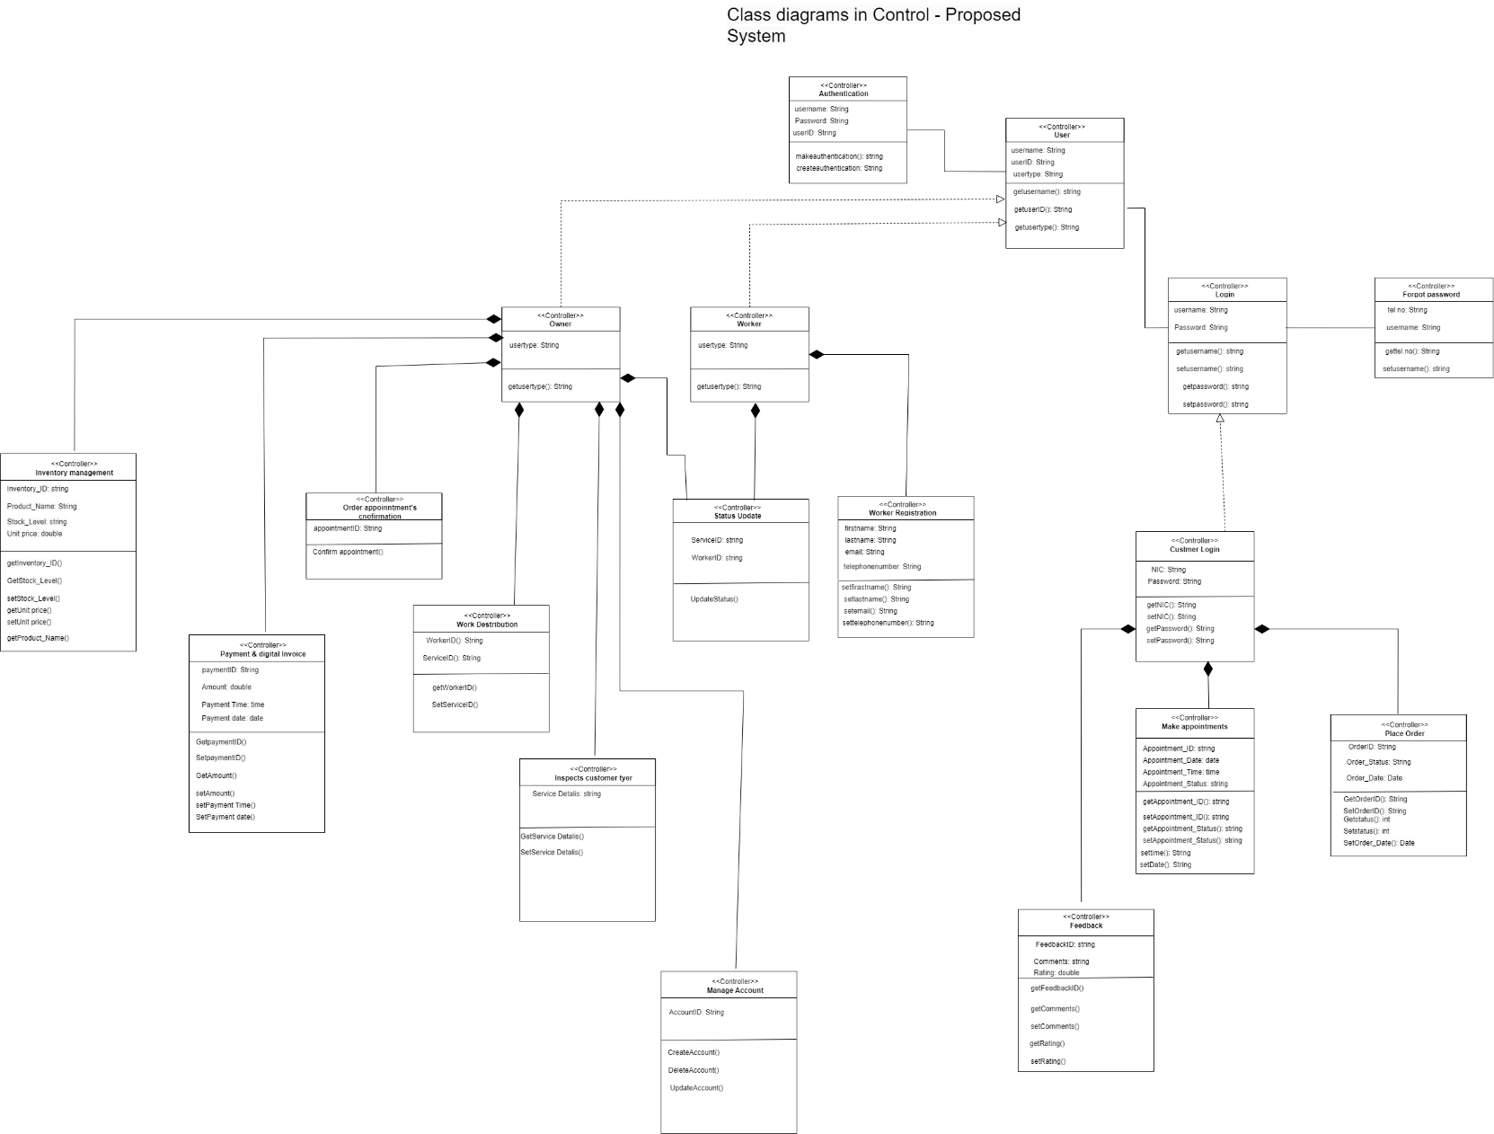

Figure 0‑13 Controller Class diagram for the proposed system

### **3.4.3 Interface Class diagram for the proposed system**

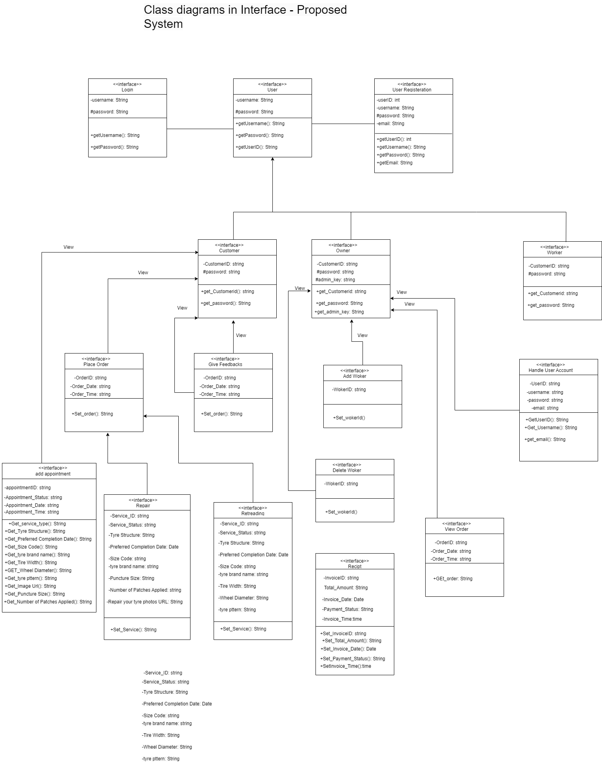The following diagram demonstrates the interface classes with their methods and attributes of the proposed system.



Figure 0‑14 Interface Class diagram for the proposed system

## **3.5 Sequence Diagrams for the Proposed System**

This section presents sequence diagrams for the proposed system, illustrating time-ordered interactions between actors and objects. Each diagram shows lifelines for actors, with arrows indicating the flow of messages to complete tasks like service requests and payments, clarifying the system's key processes.

**3.5.1 Sequence diagram for login** 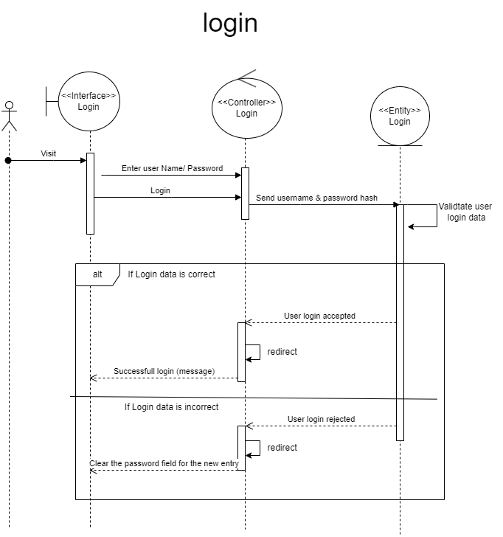

Figure 0‑15 Sequence diagram for login

### **3.5.2 Sequence diagram for Create Account**

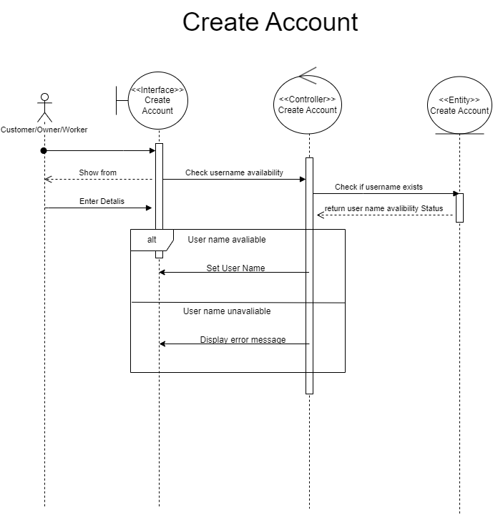

Figure 0‑16 Sequence diagram for Create Account

### **3.5.3 Sequence diagram for Place Order**

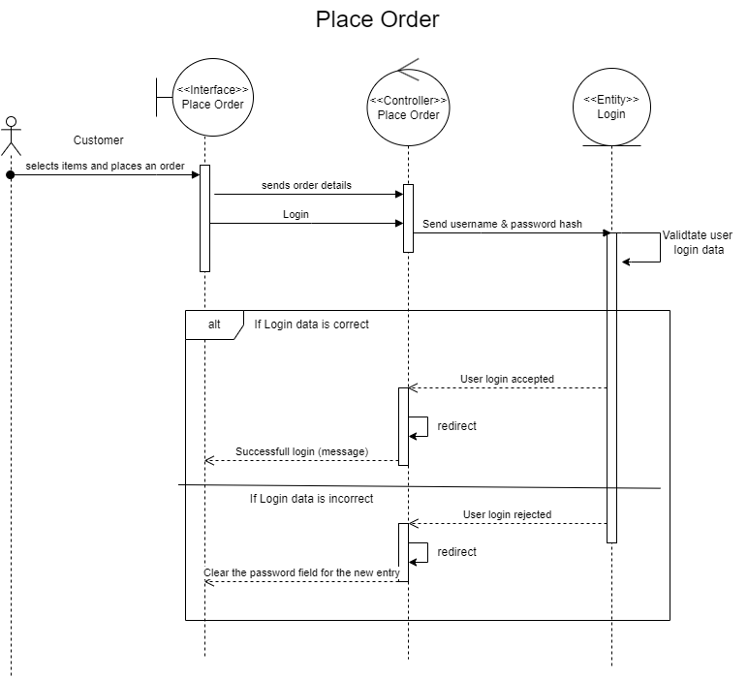

Figure 0‑17 Sequence diagram for Place Order

### **3.5.4 Sequence diagram for Work Distribution**

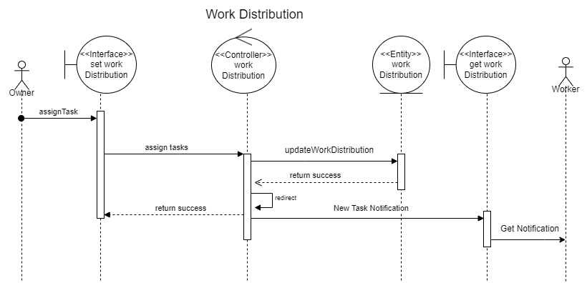

Figure 0‑18 Sequence diagram for Work Distribution

### **3.5.5 Sequence diagram for Owner Inspects Customer Tyre [in place]**

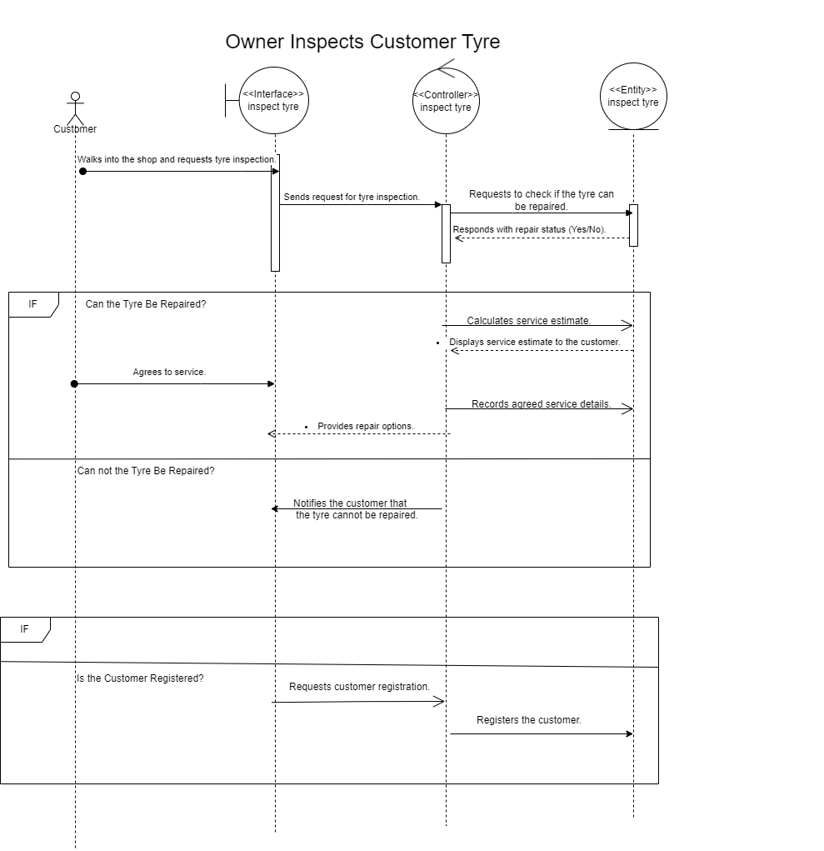

Figure 0‑19 Sequence diagram for Owner Inspects Customer Tyre [in place]

### **3.5.6 Sequence diagram for Payment & Digital Invoice**

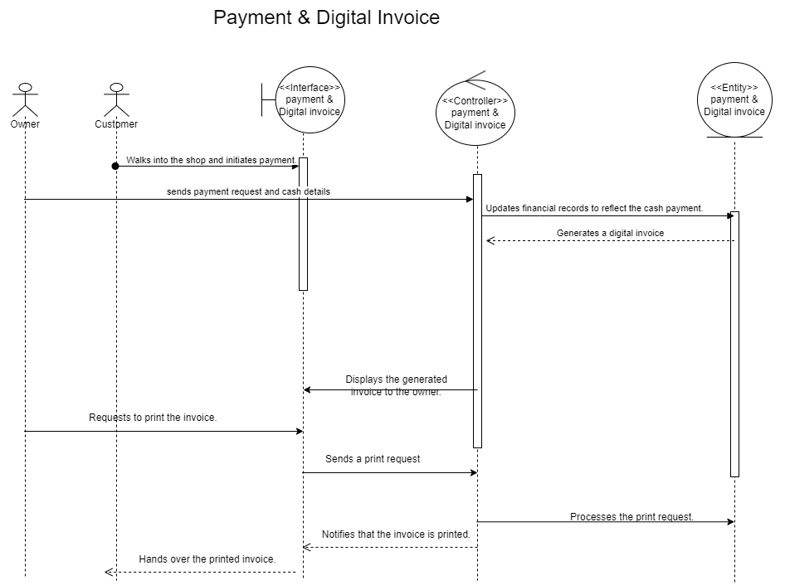

Figure 0‑20 Sequence diagram for Payment & Digital Invoice

**3.5.7 Sequence Diagram for Customer Feedback**

Figure 0‑21 Sequence diagram for Customer Feedback

**3.5.8 Sequence diagram for Inventory Management**

Figure 0‑22 Sequence diagram for Inventory Management

### **3.5.9 Sequence diagram for Manage Account**

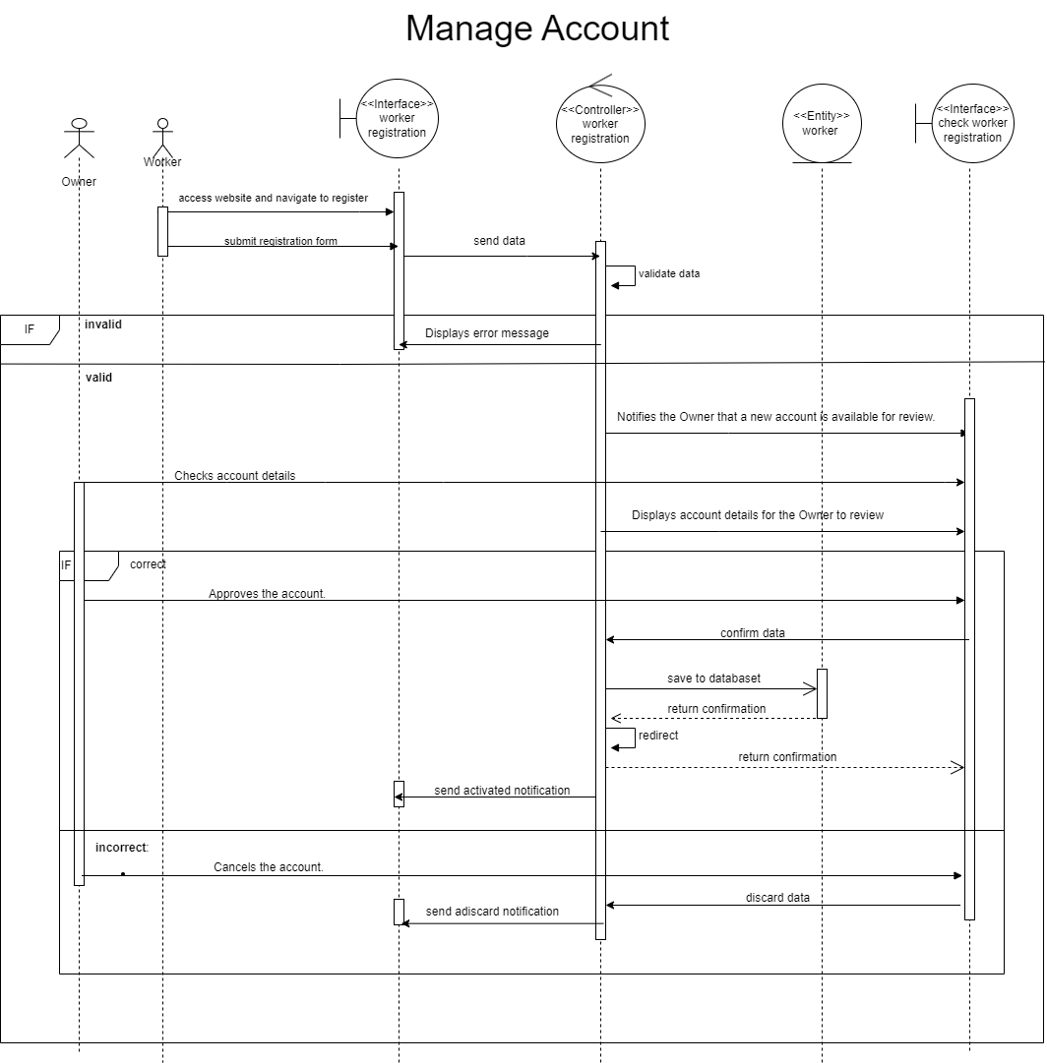

Figure 0‑23 Sequence diagram for Manage Account

## **3.6 Normalized Database Design**

A normalized database design is essential for maintaining data integrity, minimizing redundancy, and enhancing query efficiency within the system. The ER diagram and relational database model illustrate a well-organized data structure, supporting smooth operations and reliable data handling throughout the system.

### **3.6.1 Entity Relationship Diagram**

The ER diagram acts as a critical framework for the system, mapping out the entities and their relationships to provide a clear view of the data structure. It helps define how different data elements interact, ensuring an organised and efficient database schema.

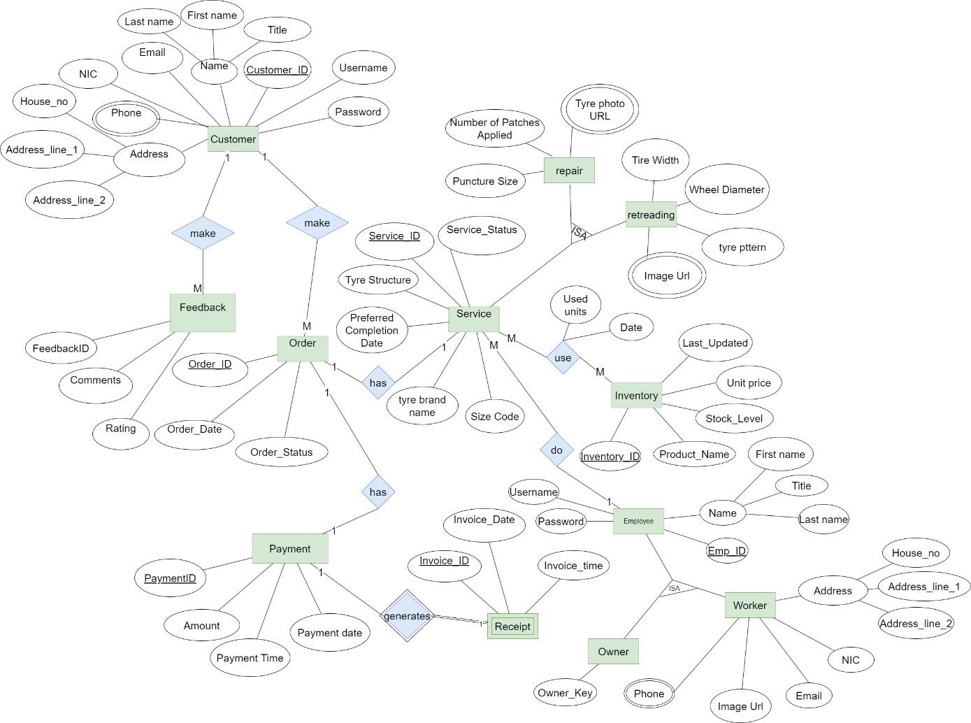

Figure 0‑24 Entity Relationship Diagram

### **3.6.2 Relational Database Model of the Proposed System**

The Relational Database Model offers an organized structure for managing the system's data, and establishing tables, relationships, and constraints to maintain data integrity and support efficient queries. By transforming the conceptual design of the ER diagram into an actionable database schema.

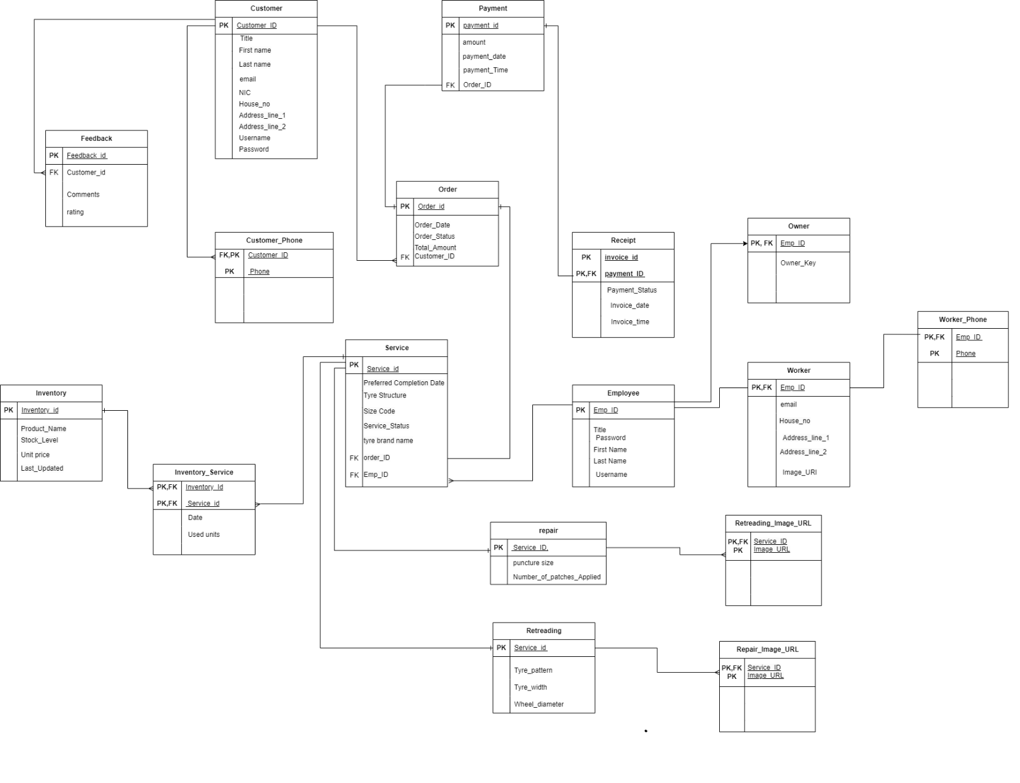

Figure 0‑25 Relational Database Model of the Proposed System

### **3.6.3 Relational schema**

**Customer** (Customer_ID, Title, FirstName, LastName, Email, Phone, House_no, Address_line_1, Address_line_2, username, password)

**Order** (Order_ID, Order_Date, Order_status, TotalAmount, *Customer_ID)

**Service** (Service_ID, Service_Type, Tyre_Structure, Size_code, Preferred_completion_Date, Service_Status, Tyre_Brand_Name, *Employee_ID)

**Inventory** (Inventory_ID, Product_Name, Stock_Lavel, Unit_price, Last_updated)

**Appointment (**Appointment_ID, Appointment_Date, Appointment_Time, Status, *Customer_ID)

**Employee** (Employee_ID, Title, First_Name, Last_Name, *Service_ID)

**Worker (**Worker_ID, Phone, Email, Assigned_Service_ID, House_no, Address_line_1, Address_line_2, username, password**)**

**Owner (**Owner_ID,username, password, secret_key**)**

**Payment** (Payment_ID, Amount, Payment_Date, Payment_Time)

**Feedback** (Feedback_ID, Rating, Comments, *Customer_ID)

**Receipt** (Invoice_ID, Invoice_Date, Total_Amount, Payment_Status)

**Repair** (Service_ID, Puncture Size, Number of Patches Applied, Repair_your_tyre_photos)

**Retreading** (Service_ID, Tire Width, Wheel Diameter, Tyer_Pattern, Image_URL)

**Inventory_Service (**(Inventory_ID, Service_ID, used units, Date**)**

**Retreading _Image_URL (**Service_ID, Image URL**)**

**Repair_** **Repair_your_tyre_photos (**Service_ID, Repair_your_tyre_photos**)**

**Customer_Phone (**Customer_ID, Phone**)**

**Worker_Phone (**Worker_ID, Phone**)**

## **3.7 GUI Wireframes**

A **Graphical User Interface (GUI) wireframe** is a low-fidelity visual guide or blueprint for a software application's user interface. It illustrates the structure, layout, content organization, and overall flow of the interface

### **3.7.1 Home Page of the Website**

  
Following Is the home page of the system which will be seen when someone searches the site in the website. From here according to the respective roles users can login to their respective user interframes easily.

Figure 0‑26 Home Page of the Website

### **3.7.2 Select Role**

This web page is designed as a role . It features three main options for users to choose their role: Owner, Worker, and Customer. Each role has a dedicated Register button, allowing users to sign up based on their specific role in the system.

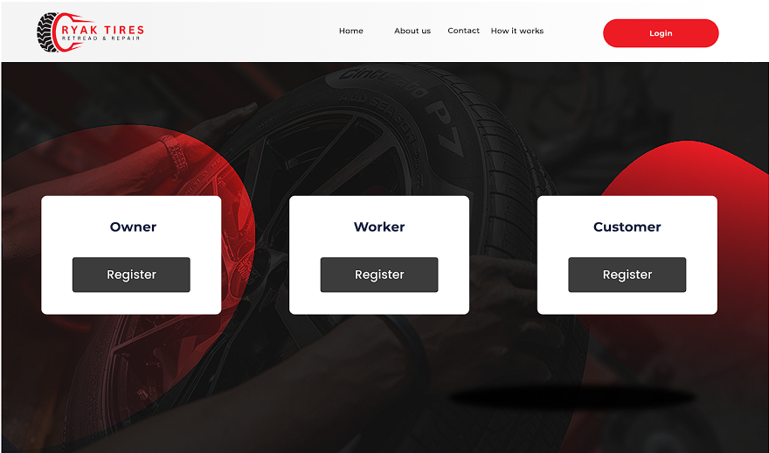

Figure 0‑27 Select Role

### **3.7.3 Owner Login**

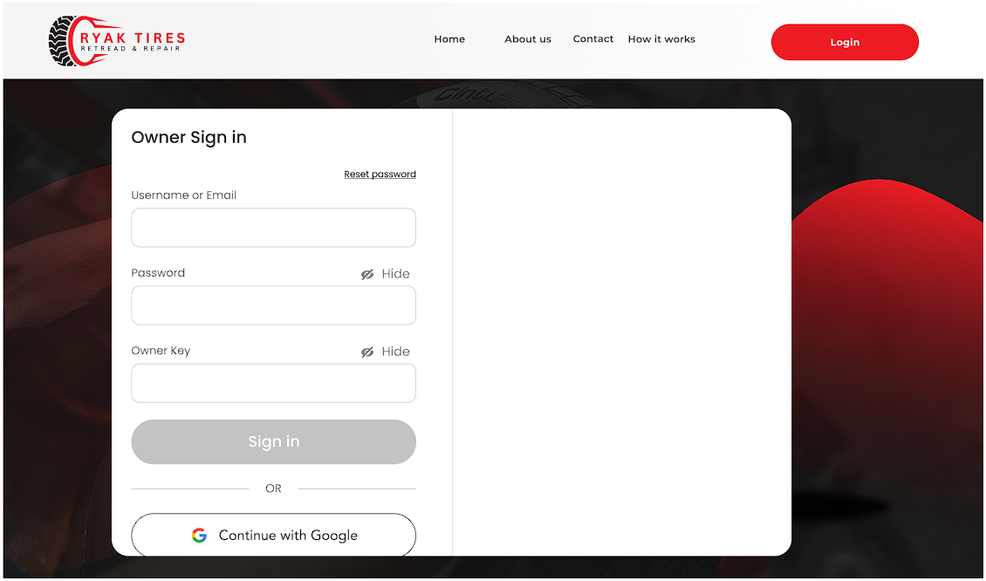This page is the Owner Sign-in interface for the "Ryak Tires" website. It includes fields for Username or Email, Password, and a unique Owner Key, which serves as an additional security measure specifically for owner accounts. There’s aa link for Reset Password in case users need assistance with account recovery.

Figure 0‑28 Owner Login

### **3.7.4 Worker Login**

This page is the Worker Sign-in interface for the "Ryak Tires" website, tailored specifically for workers logging into the system. It includes fields for Username or Email and Password. There is a Reset Password link for workers who may need help recovering their login information.

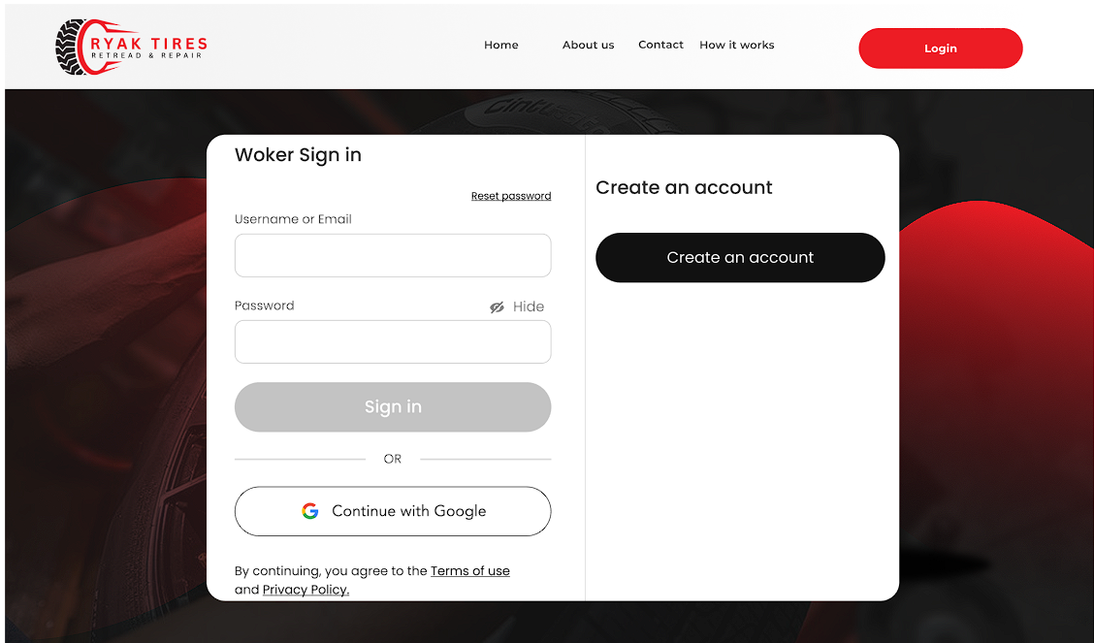

Figure 0‑29 Worker Login

### **3.7.5 Customer Login**

This page is the **Customer Sign-in** interface for the "Ryak Tires" website, tailored specifically for Customer logging into the system. It includes fields for **Username or Email** and **Password**. There is a **Reset Password** link for Customer who may need help recovering their login information.

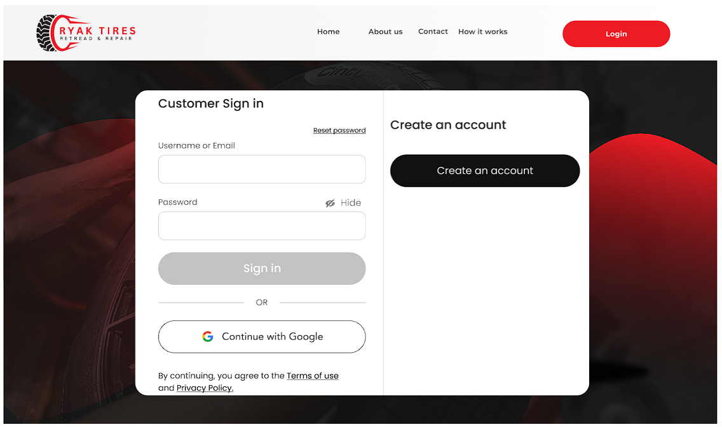

Figure 0‑30 Customer Login

### **3.7.6 Worker Registration**

This page shows a "Worker Registration" form for a business named "Ryak Tires Retread & Repair." The form is designed to collect worker information such as their first and last names, title, email, phone numbers, NIC (national ID card) number, and address details. It also includes an option to upload a profile picture.

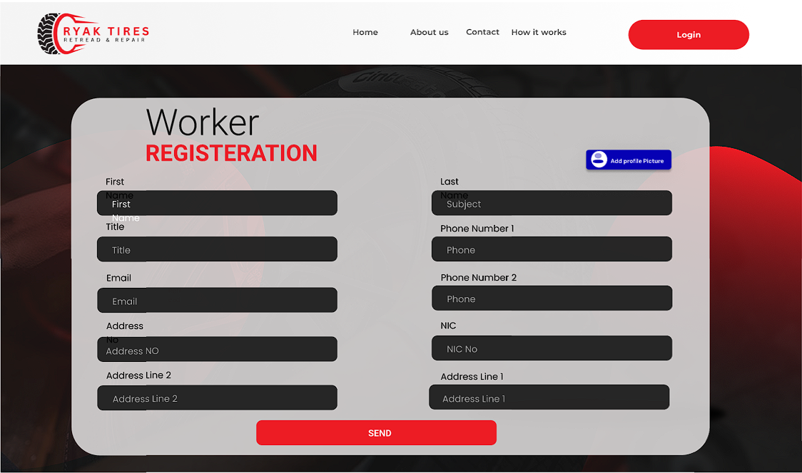

Figure 0‑31 Worker Registration

### **3.7.7 Customer Registration**

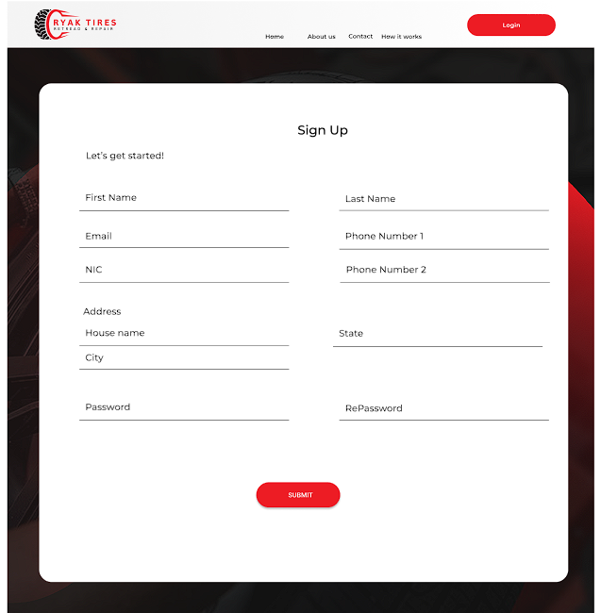Sample registration interface for customers. It includes a list of fields that a user will input data  into and submit by clicking on ‘Create account’ button. Users also should input a username and  other details for their account through the registration interface.

Figure 0‑32 Customer Registration

### **3.7.8 Customer Dashboard**

The customer dashboard for "Ryak Tires Retread & Repair" serves as a welcoming interface where users can easily access essential tire repair and retreading services. Quick navigation links allow users to explore more about the business, contact support, or log in to their account. This dashboard is designed for a seamless, user-friendly experience, guiding customers to act effortlessly.

Figure 0‑33 Customer Dashboard

### **3.7.9 Owner Dashboard**

The Owner Dashboard for "Ryak Tires Retread & Repair" is a streamlined interface designed to help business owner to manage operations efficiently. Key features include the ability to approve customer orders, assign workers to specific tasks, and approve new workers.



Figure 0‑34 Owner Dashboard

### **3.7.10 Worker Dashboard**

****This is the Worker Dashboard for "Ryak Tires," a tire repair and retreading service provider. The dashboard serves as the primary interface for workers, offering quick access to key tasks and information.

Figure 0‑35 Worker Dashboard

### **3.7.11 Approve Order**

The Order Approval Interface is designed for the owner or admin of the business to manage orders submitted by workers. It allows the owner to easily review, approve, or cancel each order. This ensures that the owner has oversight of ongoing work, maintains quality control, and ensures customer satisfaction by managing service schedules effectively

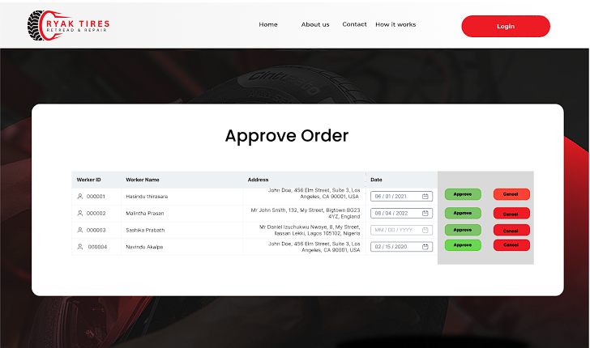

Figure 0‑36 Approve Order

### **3.7.12 Approve Worker**

The Worker Approval Interface is designed to allow the business owner to review and approve or reject applications from potential workers. This interface gives the owner control over who joins the team, ensuring only qualified individuals are selected.

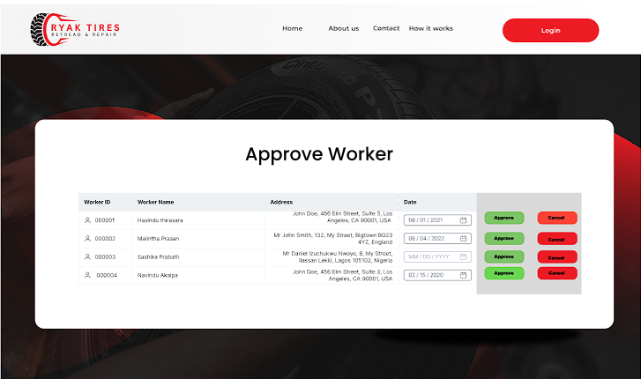

Figure 0‑37 Approve Worker

### **A screenshot of a computer Description automatically generated3.7.13 Assigning Worker**

Figure 0‑38 Assigning Worker

### **3.7.14 Assigning Worker Select**

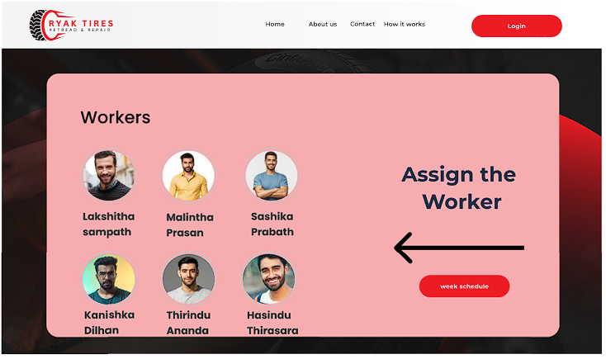

Figure 0‑39 Assigning Worker Select

The Worker Assignment Interfaces are designed for the business owner or manager to assign specific tasks or jobs to approved workers. This helps organize work distribution, ensures tasks are covered, and tracks who is responsible for each job.

### **A screenshot of a computer Description automatically generated3.7.15 Worker Add the Task**

Figure 0‑40 Worker Add the Task

This form will show the owner the works assigned to each worker and he can select the most suitable worker and assign the task from here.

### **3.7.14 Choose the service**

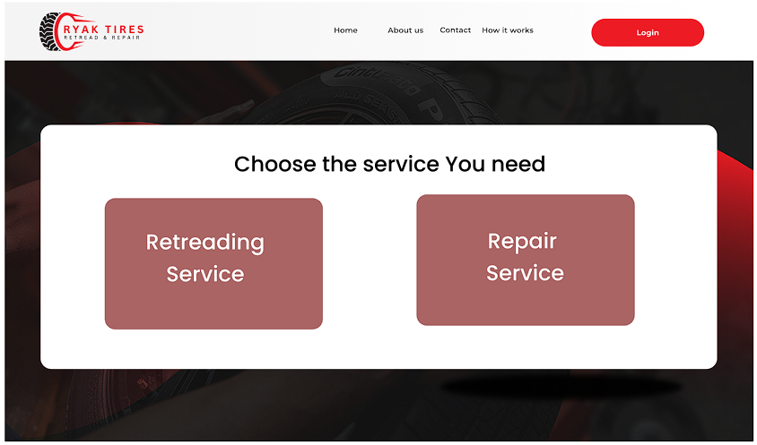

Figure 0‑41 Choose the service

This tab enables customers to easily choose the type of service they need for their tires—either Retreading or Repair—and proceed with order.

### **3.7.15 Retreading Service**

Retreading Service Form is a structured form layout designed for customers to easily provide all the necessary details. This form will help ensure that the retreading service request includes specific information about the tire(s) so that the business can deliver accurate service.

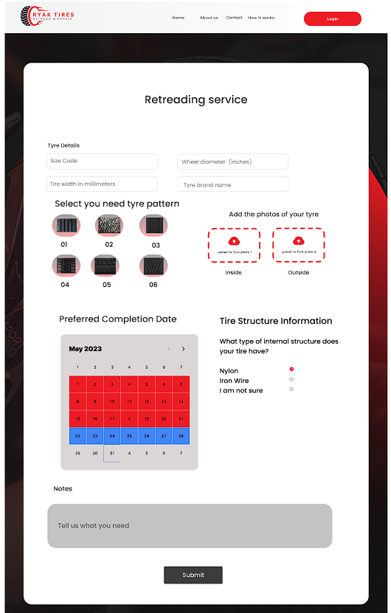

Figure 0‑42 Retreading Service

### **3.7.16** **Repair Service**

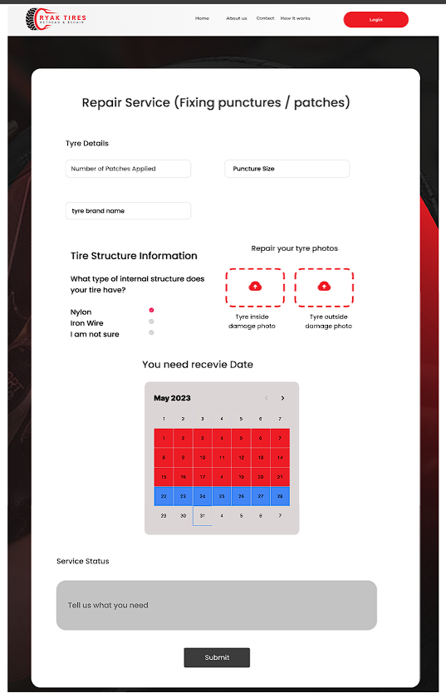

Figure 0‑43 Repair Service

Repair Service Form is a structured form layout designed for customers to easily provide all the necessary details. This form will ensure that the retreading service request includes specific information about the tire(s) so that the business can deliver accurate service.

### **3.7.17 Successful Massage**

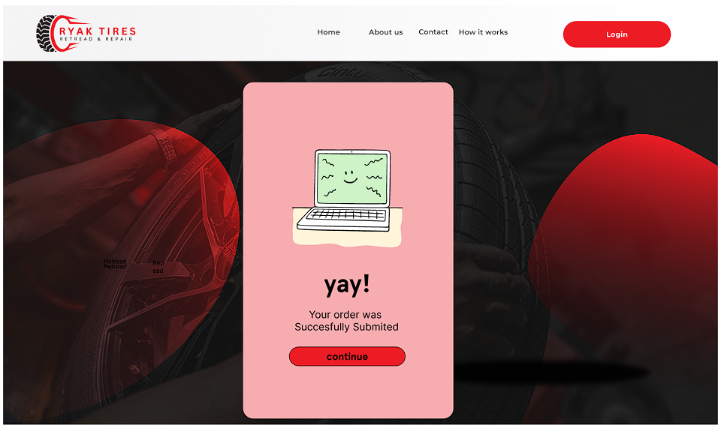

Figure 0‑44 Successful Massage

### **3.7.18 Worker Tasks**

When the worker has completed his work he can use this form to update that he has completed the work in the system. This gives an easy and clear interface to the wprkers to do that.

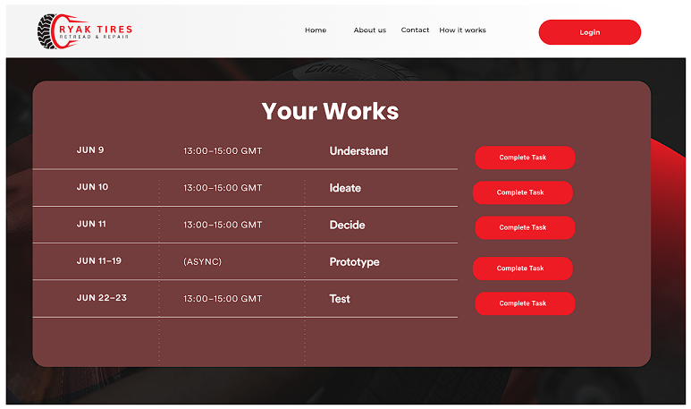

Figure 0‑45 Worker Tasks

# **CHAPTER 4 - System Architecture Design**

System architecture pattern represents a high-level structure or blueprint for organizing the components, modules, and interactions within the system to achieve its goals. Following is the proposed system architecture design for the Tyre retreading and repair management system,

### **4.1 Physical Architecture (MVC)**

As for physical architecture, the chosen architecture is MVC architecture. The main components include Client devices, Web or application server and the database server.

1. **Client Devices:** User devices such as Desktop PCs, laptops, tablets, and smartphones. Are included. Used by the owner, workers and the customers interact with the system. These devices work with the web server through the internet.

**Web / Application Server:**

Application logic (Controller) and user interface (View) are hosted in this server. It Processes user requests, handles business logic, and communicates with the database server.

1. **Database Server:**

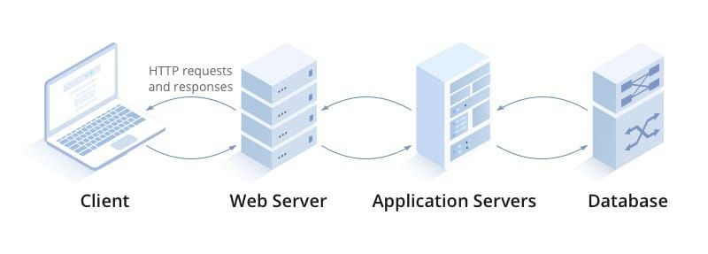This stores data for orders, order status, customer details, work allocation, billing, and user accounts. And it manages and processes queries from the application server.

Figure 0‑1 Physical Architecture (MVC)

### **4.2 Logical Architecture (MVC)**

The logical architecture focuses on how the software components are structured and interact in the MVC framework.



**View layer**.

This provides the user interface for owner, customers and workers. It Uses React components to handle UI rendering and user interactions. This layer makes HTTP requests to the backend. ReactJS will be used as the technology.

**Controller layer**.

Receives requests from the frontend (React.js). This layer contains business logic for processing requests (e.g., make orders, handling user authentication, managing customer details).NodeJS will be used as the technology.

**Model layer**



Database (MySQL) will be used as the model layer. It manages data storage and retrieval for customer information, orders, workers, payment details, and user accounts.

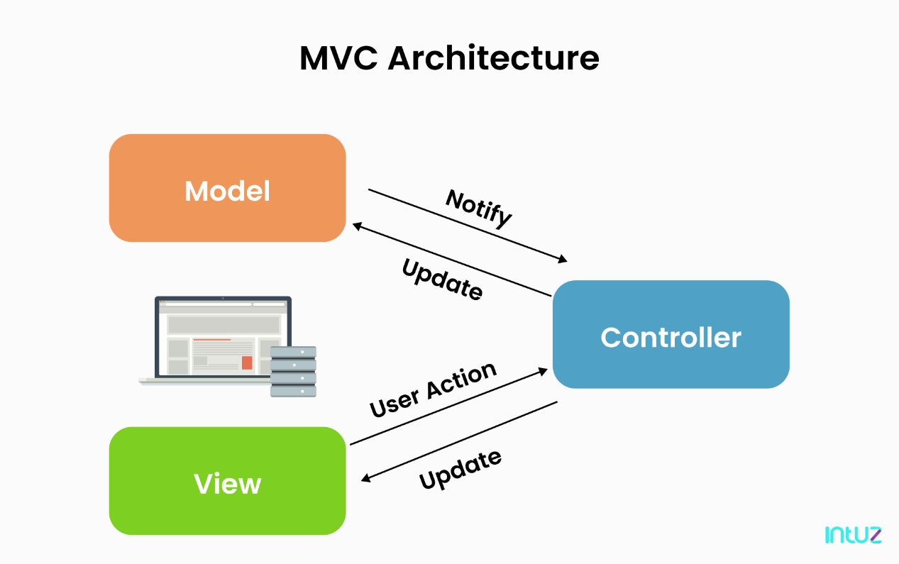

Figure 0‑2 Logical Architecture (MVC)

# **CONCLUSION**

The proposed Tyre Retreading and Repair Management System aims to resolve existing challenges while establishing a solid foundation for a more organized, collaborative, and communicative work environment at **RYAK TYRES**. By streamlining operations and automating manual processes, the system enhances efficiency and reliability, leading to better management of the business's daily tasks.

In conclusion, this report captures the entire journey from problem identification to developing a tailored intranet solution. It focuses on addressing the medical centre's specific needs, paving the way for a robust and efficient system that supports seamless patient care and improved operational performance.